St Clement’s C. of E. Primary School

The teaching & learning of Reading in our school

Adopted by HSH & JY (English Leads) and approved by JP (Head): September 2022
Due for review: September 2023

Growing Together To Let Our Light Shine
Mission Statement:
We encourage and inspire children to aim high and challenge themselves in everything they do.
As a compassionate, Christian school, we are strong in our faith. We believe in love and forgiveness and are thankful for the opportunities we have to live and learn in our community.
(REVIEWED JUNE 2020)

Our Christian Values
Faith
Hope
Love
Respect
Thankfulness
Compassion
Forgiveness
(September 2017)
DDA STATEMENT
At St. Clement’s we will aim to:
- Promote equality of opportunity between disabled people and others.
- Eliminate discrimination that is unlawful under the Act.
- Eliminate harassment of disabled pupils that is related to their disabilities.
- Promote positive attitudes towards disabled people.
- Encourage participation by disabled people in public life.
- Take account of a disabled person’s disabilities, even when that involves treating a disabled person more favourably than another person.

Rights Respecting School Link to Articles: 3, 8, 12, 13, 14, 16, 17, 23, 27, 28, 29, 30, 31, 32, 36, 39,

Reading in our school:
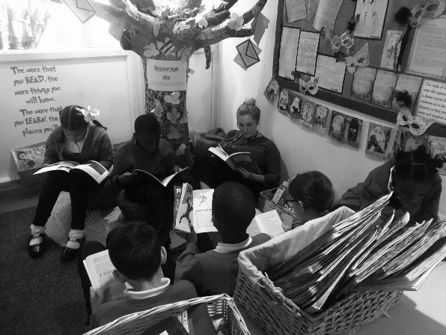

At St.Clement’s, we value reading as a key life skill and we are committed to enabling our pupils to become lifelong readers. We believe reading is key for academic success and so to ensure we have a consistent and motivating approach to the teaching of reading, we implement the following:

- From Reception to year 6, children take part in focussed Guided Reading lessons, where children are exposed to a range of different text types and authors and will work on developing specific reading skills linked to the Reading Gems (the reading assessment focuses/domains).
- Children who are not yet ‘free readers’, will work through our school reading scheme – these are levelled books which match the children’s current reading age. We expect family at home to read these books with their child daily and make comments in their child’s reading record.
- Shared reads are an essential part of our curriculum, where teachers read aloud to their students and model the reading process/strategies. Pupils are encouraged to track the text that is being read aloud and may repeat or chorus parts of the text. Teachers will chose books that have the potential for teaching new vocabulary, language and sentence structures or to expose them to a specific author’s style. Although the chosen text may be difficult for some pupils to access, they may have strong comprehensions, high-inference skills they can develop further by being read to by a teacher. Provision may be also be put in place, so these pupils can access the text e.g. a pre teach, exploring the vocab before a session, but we feel exposure to more challenging texts can have an impact on pupils’ reading skills.
- We want to expose our pupils to a range of authors, so they can explore and discuss different author’s styles and comment on the impact of the author’s style. Hopefully, pupils will explore using such styles in their own writing and ultimately they are inspired by the different authors they are exposed to and strive to become poets, journalists, novelists, playwrights.
- Through exposing pupils to a range of genres, reading opportunities and different authors we strive to improve pupils understanding and use of vocabulary an area we have identified as needing to be at the forefront of our teaching and learning. The Define and Explore Gem are key Gems we focus on to develop pupils’ understanding of and use of vocabulary and through shared reads and guided reads these Gems are at the forefront of the teaching and learning.
- We want to develop children’s understanding that author’s word choices (The Explore Reading Gem), are carefully thought out, and during sessions the intent and impact of authors’ word choices will be analysed and discussed, which supports with the our approach to the teaching of writing and supporting our own pupils to become successful authors.
- Each class has their own reading area, with a selection of books suitable for their reading age. Pupils can choose a reading book to take home and this can be changed when the child has finished with it. Parent/carers or pupils record what they are reading in their home reading records. At times, we direct pupils what to read, but we do want pupils to develop a love for reading and so we believe they should read what appeals to them/interests and inspires them. Reading areas also provide recommended texts, extracts, books to entice pupils to read; selected challenge books to challenge pupils and picture books – as we believe picture books in all year groups are an extremely powerful resource to engage pupils to read and develop their reading skills further.
- We are determined to develop a rich reading environment for our pupils, and are trying to set up reading opportunities throughout the school e.g. under the reading tree in the entrance hall, the garden library, and also outdoors – e.g the reading shed, which is run by selected pupils, who are loyal, motivated reading leaders.
- We have invested in using Oxford Reading Buddy to promote reading further in school and at home. It is a digital reading service that supports a child's personal reading journey, motivates them to succeed, and provides teachers with valuable insights into their attainment and development.
- Children are read to by their class teacher – this may be a class novel, or an extract the teacher would like to share with their class. This could be a book that the teacher recommends to the class or a recommendation from a child.
- Children have the opportunity to take part in ‘Reading Buddies’, in which children mix with other children from different year groups and share a book together.
- Pupils may be sent home extracts, texts and books as part of their Guided Read session.
- Children who are not yet ‘free readers’, will work through our school reading scheme – these are levelled books which match the children’s current reading age. We expect family at home to read these books with their child daily and make comments in their child’s reading record.
- We have a resident author ‘Matt Goodfellow’, who inspires our pupils to develop a love for poetry and reading!
- We join in with national Empathy Days in the month of June, where we share and read empathy-boosting books with our pupils to develop their understanding of the importance of empathy.

By the time children leave our school, we strive to ensure they are competent readers, have an improved understanding and use of vocabulary. We want our pupils to have developed a love for reading and a thirst for reading a range of genres including poetry and develop a love for a range of authors and are inspired authors or what they have read. We want our pupils to recommend books to others, and participate in discussions about books, including evaluating an author’s use of language and the impact this can have on the reader, and the impact literature can have on us altogether. Ultimately, we also want our pupils to realise they are aspiring authors themselves.

The teaching & learning of reading in our school:
Previous messages from Reading Staff training:

Shared reading in our school:
Shared reading is a whole class approach to the teaching of Reading. Gems need to be embedded in shared reading across the curriculum.

1. All children should be in mixed-attainment pairs, Literacy threes, so as to allow for frequent, paired/group discussion - It is essential that less confident readers are exposed to the high-quality reasoning of more confident readers and become part of these discussions.

2. The text chosen should provide a clear challenge for all members of the class
The text chosen should be between 12 months beyond the reach of your higher attaining readers; that is to say, beyond the reach of their independent reading of it and comprehending of it.

3. When reading, the teacher should model good use of intonation, movement, volume and expression
Children will pick up good reading styles from teachers’ performances. Eventually, they will start to emulate you in their own performances.

4. Teachers should be actively monitoring pace, so as to ensure high levels of engagement throughout the lesson

Reading and listening to reading for long periods of time can be mentally taxing for some children. Interspersing longer stints of reading with paired discussions/independent follow-up tasks can help with this – continue to do a range of reading activities – these can be complete independently or in Literacy three and recorded in Literacy Three Books or exercise books if completed independently. (See examplars) Independent follow-up tasks should be carefully thought out, to provide challenge for all children and support for those who need it.
A follow-up task is a good way for children to reflect on what they have read in the shared read and an opportunity for the teacher to observe/assess the individual understanding of the shared text. Differentiating these tasks should not be onerous; simple tweaks are often enough e.g.

5. Teachers should use targeted and open-ended questioning and link them to the Reading Gems:

The Gems should be constantly be referred to and actively used in all shared reading, so pupils are extremely familiar with the different domains of the reading gem and the reading skills they are helping them to develop.

6. When discussing literature, the teacher should model, and expect from children, high-quality responses with evidence and explanations provided to support.
Children need to be able to say a response before they can write one; developing this skill in primary is vital for success at secondary and beyond. Teachers should model and encourage children to make good use of sentence stems and the Evidence and explain prompts (eg," The author has used the word ___________ to suggest ____________ , as the word ________ has connotations of __________" )
Use the GEM stems (available for EYFS – KS2)to support develop this talk and the Evidence and Explain prompts (E&E) to support pupils to answer questions in more depth:
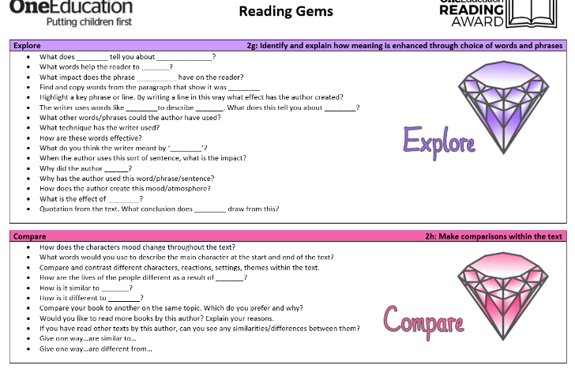
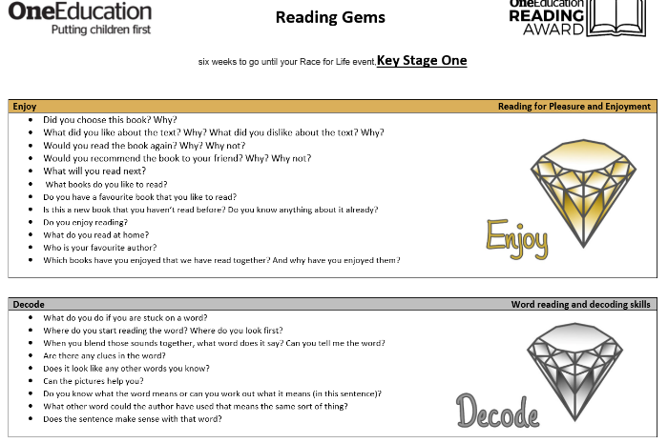
Example of the GEM stems:

Example of the prompts to support pupils developing their answers:

Shared reading needs to take place across the curriculum – and the Gems need to be continued to be embedded in a range of texts or activities across the curriculum, in order for the teaching of GEMs to be securely embedded. (See examples shared in training 03/03/2020)
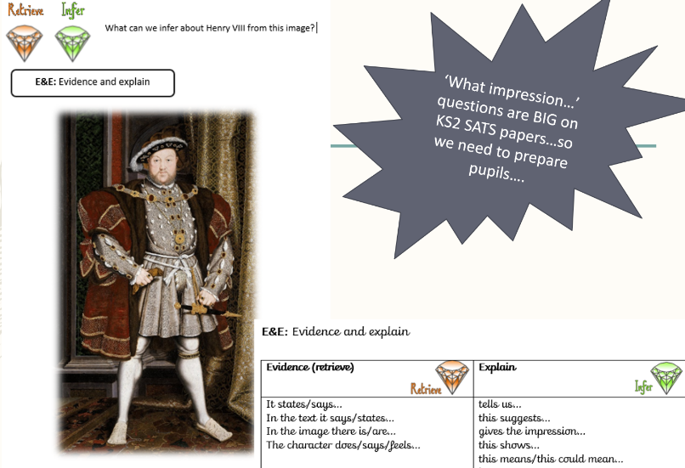

Guided reading:
To meet the needs of the pupils of St. Clement’s we feel our pupils need to have dedicated time given to the teaching of reading in small groups, as a lot of pupils are not always reading at home or are not reading at the expected age for their year group. However, in some classes, where pupils are reading at the same level may be exposed to the same text and then focussed groups will have focussed reading Gem questions to address gaps identified from assessment. The More Able pupils will have reading tasks designed to challenge their thinking and enhance their reading skills even further.
Where needed, we believe guided reading is beneficial for our pupils, as small group (no more than 6) work gives pupils the focus they need in order to support their progression in reading and it allows teachers to take pupils on a personalised reading journey, as Simon Smith (Head teacher/Advisor in Reading) states:
‘Guided Reading takes a small group on a journey with a book and really explore it.’
We propose the teaching of 1 GEM or more dependent on the needs of the group should be focussed on for the week and obviously Gems which pupils are secure with/have been a previous focus will be continuously embedded in the teaching and learning of reading in guided reading sessions. However, in many reading tasks it is apparent pupils will be applying a range of reading gems.
Example of a task where the focus is developing inference, but pupils will have to apply their retrieval skills to answer the question.

Obviously, pupils will have to apply other reading skills for example the Define and explore Gem in order to understand the vocabulary and language being used to describe the characters in the book. However, these GEMS will most probably have been explored and applied in a previous session focussed on the define and explore GEMS so pupils could access this question.

In the guided reading session teaching staff are practising modelling how to tackle the specific domains of reading, and are also modelling how to tackle different styles of questions for the focused GEM being taught.

Examples of different styles of questions for the different Reading Gems/Reading domains:
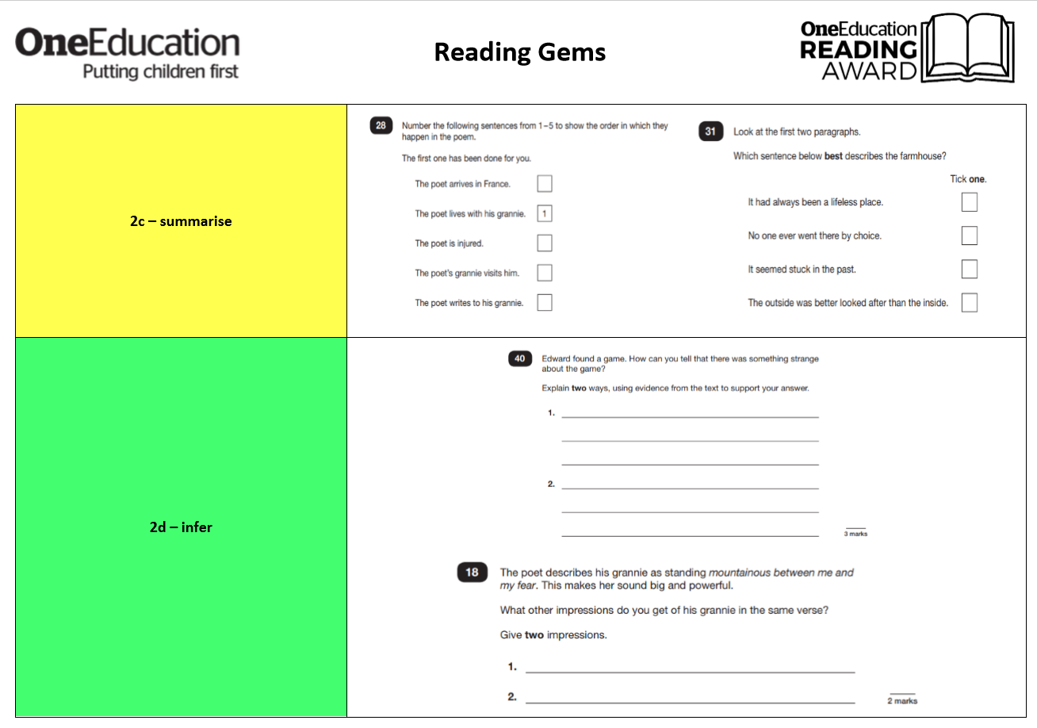
The purpose of this is to improve pupils’ understanding of the Gems and enable pupils to become confident and secure with tackling a range of different style of questions linked to the reading domain. Obviously, pupils should be exposed to the other Gems within a guided reading session, but the teaching of 1 Gem in in depth should be explicit.
The grouping of pupils in guided reading:
It is essential teachers are responsive with grouping of pupils in guided reading – they may need to change in accordance to assessment of pupils and in response to what the analysis of the NTS tests or other reading assessments carried out present. Pupil’s gaps should be identified and groups should be changed to cater for the gaps identified. Some pupils may need to be grouped for a specific task – e.g. focusing on a specific Gem they need more support with/they may need more challenge in an area of reading. Choose a text age appropriate for the group, which will support them develop the reading skills they are working on.
If pupils are reading at the same age – the same text can be for more than 1 group if it appropriate for the groups needs/areas in reading they need to work on.
More able pupils should be given challenging texts, as their reading age will be higher than their peers. The text should challenge them in all areas of reading and stimulate group discussions. The text should expose MA pupils to more ambitious vocabulary, and promote exploration of the vocabulary. MA able pupils will most probably be being exposed to a range of GEMs to challenge their thinking and when confident could possibly begin to write their own GEMs.
What can other pupils being doing during a Guided Reading Session?
As agreed, when pupils are not having a guided reading session with the teacher or teaching assistant, they should be doing an activity which will continue to support pupils to develop/enhance their reading skills or promoting a love of reading. Planning for these activities does not need to be onerous – once resources are made for a particular activity they can be re-used. Please see possible ideas below:
Possible ideas:
- A prep task to prepare for the guided read session with the teacher/A follow up task in response to a guided read session.
- Focused Gem tasks as a follow up/application activity to embed learning from a Guided Read, where they have practised the reading skill which has been explicitly taught by a teacher.
- EY2P Reading Activities can still be used, however just be mindful the purpose of the activity is to enhance
- Treasure chests (see examples)
- Vocab activities around a text (using ideas/activities from ‘Vocab training’)
- Paired reading
- Pleasure for read – using dictionary to clarify meanings of unfamiliar words (could record in journals) or write recommendation notes for what they have read to their peers.
- Reading for fluency – provide pupils wilt texts with specific numbers to try and read in a set time to promote fluency.
- Reading picture books to develop a love for reading and inference.
- Exploring picture books together – give pupils some questions to discuss together.
- Opportunities to explore non-fiction books/texts (See activity sheet for Sharks)
- Group discussions/debates around a given book/text (P4C style questions)
- Read article/s from the First Newspaper – a range of valuable activities for this are available on the link HSH sends via email weekly.
- Read ‘The Week’ magazine and group share/record interesting information they have read about or give them a
- Reading a range of blurbs and writing views on the impact of the blurb/predictions about the texts etc
- Comparing front covers of books and predicting/inferring from the front covers.
- Reading a short passage and exploring the vocabulary (define and explore reading Gem)
- Explore/discuss/compare/read aloud a range of poems.
- Give groups an image from a book/or an image which will promote discussion/develop inference – what is happening/what is the story behind the image?
- Reading for Empathy – lots of great texts to promote empathy and then pupils could complete tasks linked to the text they have read.
- Short texts in boxes (kept in Literacy room) to promote reading for fluency and developing comprehension.
- Read materials from the teachers’ recommendation basket.
- Read materials from the topic baskets.

*Writing is allowed in Guided Reading, e.g. answering Gem questions in response to what they have just read, as long far the writing does not become the main focus and it is supporting develop their reading/comprehension skills. In the older year groups pupils will most probably be writing more as is is essential they practise their written responses as well as their oral responses and also to express their ideas/views about what they have read etc.
Creative Book Reviews:
All classes have an ‘Our Reading Journey’ book, where pupils are encouraged to create creative book reviews to present their views about the authors and books they have read and enjoyed and hopefully encourages others to read.
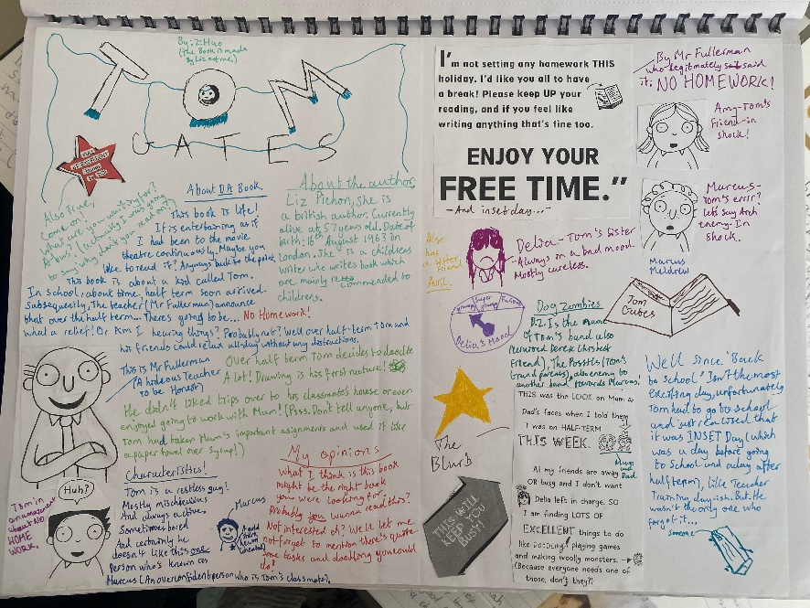
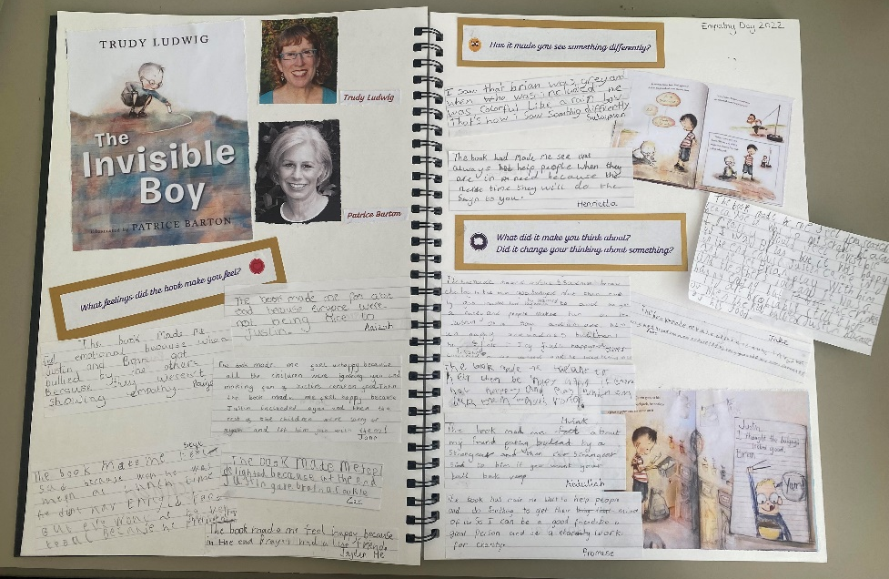

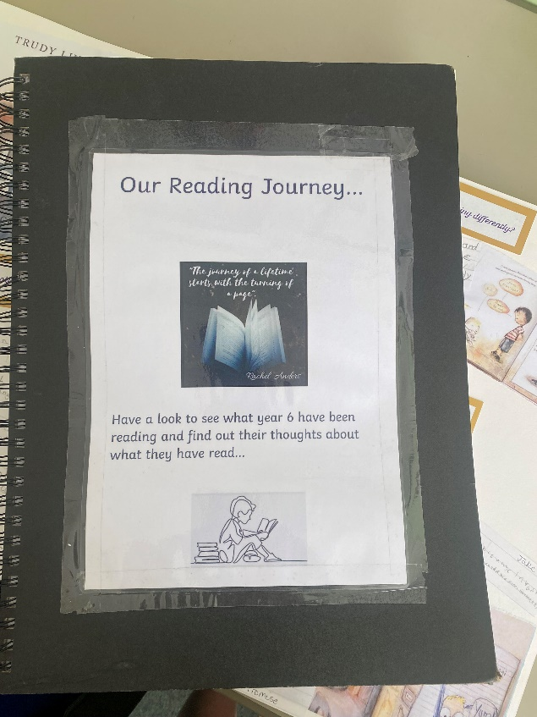

The link between writing and reading in our school:
In our writing sessions we use the Write Stuff writing lenses, which helps develops pupils’ understanding of the three writing zones in writing: Techniques, Ideas and Tools needed to create a complete piece of quality writing.

In Writing we expose children to a range of extracts, different genres and author’s and as outlined above carry out shared reads with classes. During these sessions we focus on reinforcing the teaching of the Reading Gems/Domains used in Guided Reading, but we are also developing pupils’ understanding of how the writing lenses are used to create effective pieces of writing. Therefore, we explore how authors have used the different writing lenses for purpose and impact. We discuss author’s examples and discuss why authors have used certain lenses and the impact these lenses have on the reader. We collect and display author’s examples for pupils to refer to, support their learning and inspire them with their writing and to be author’s. We also encourage pupils to find author’s examples in guided reading or when independently reading.
Examples of author’s examples and an author’s example display:

Wider Reading:

As a school we want to promote reading across the whole curriculum and expose pupils to a range of genres and authors, in order to engage them, promote a love for reading as well as developing their reading skills, broadening their vocabulary, enhancing their subject knowledge and life skills.

Class novels/reads:
In all year groups pupils will be read to for pleasure by teaching staff ; they be will read class novels, poems, extracts to promote enjoyment for reading and expose children again to a range of different reading materials and authors.
Home Reading:
Pupils should be encouraged to take reading materials home to read, these may be materials given by teaching staff or books/extracts taken from the class library. However, as a school we want to promote pleasure for reading therefore pupils should not be forced to read materials which may disengage them in reading. All pupils will take home a reading log and these should be checked by adults to ensure pupils are reading at home, older KS2 pupils are expected to independently complete their reading logs. Reading Clems, which can spent in our Clems shop, will be rewarded to pupils, who are regularly reading for pleasure at home or reading materials they are given by their teachers. Pupils are also encouraged to create creative book reviews for our class reading journey books to also receive Clems.

Let’s get children reading more, loving reading, being inspired by reading and benefiting from reading!
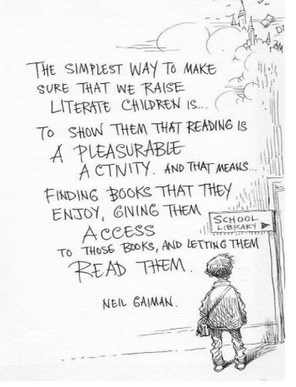
Mrs St. Hill & Miss Younge (English Leads)

