St Clement’s C. of E. Primary School

Spelling Policy

Reviewed by HSH & JY (Literacy Leads): June 2023
Approved by JP (Head): June 2023

Due for review: June 2024

Growing Together To Let Our Light Shine
John 3:18 ‘Little children, let us not love in word or talk but in deed and in truth.'
Mission Statement:
We encourage and inspire children to aim high and challenge themselves in everything they do.
As a compassionate, Christian school, we are strong in our faith. We believe in love and forgiveness and are thankful for the opportunities we have to live and learn in our community.
(REVIEWED JULY 2019)

Our Christian Values Reflected In This Policy
Faith
Hope
Love
Respect
Thankfulness
Compassion
Forgiveness
(September 2017)

DDA STATEMENT

At St. Clement’s we will aim to:
- Promote equality of opportunity between disabled people and others.
- Eliminate discrimination that is unlawful under the Act.
- Eliminate harassment of disabled pupils that is related to their disabilities.
- Promote positive attitudes towards disabled people.
- Encourage participation by disabled people in public life.
- Take account of a disabled person’s disabilities, even when that involves treating a disabled person more favourably than another person.

Rights Respecting School Link to Articles: 1, 2, 3, 4, 5, 12, 14, 16, 17, 18, 19, 28, 29 & 41.

St Clement’s C of E Primary
Spelling Policy

INTRODUCTION
This policy document has been written by the English Leads: Hayley St.Hill & Jenny Younge. It is a working document, which reflects the ethos and practice within the school in relation to the teaching of Spelling. It has been written with due regard to the requirements of the 2014 English National Curriculum and it will be monitored and evaluated according to changes within these documents as and when they arise.
As a school we continue to promote the fundamental principals of our policy, however, from September 2022, we opted to trial the Write Stuff approach to the teaching of spelling, which promotes an investigational approach into the teaching of spelling.
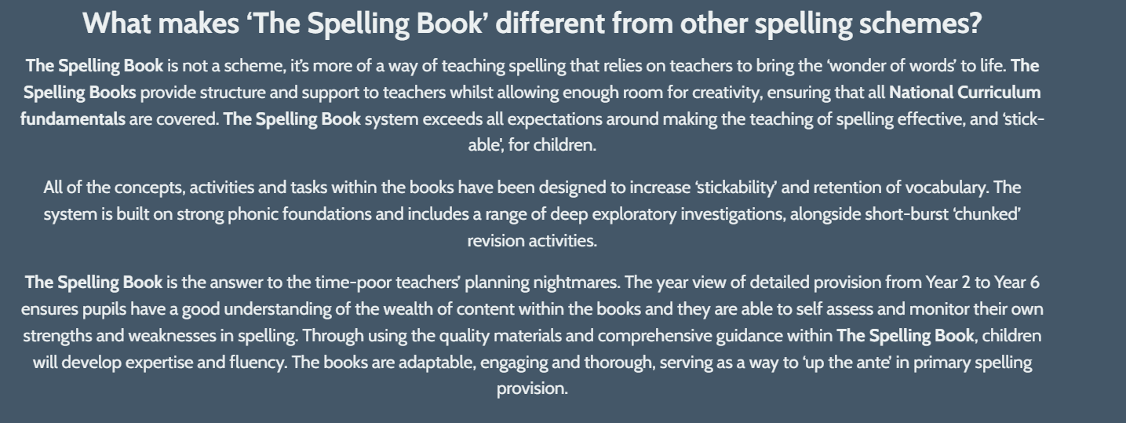
The Write Stuff approach to spelling:

In reviewing the approach teachers felt the proposed timetable was not always meeting the needs of our children or the pace of the approach was too fast to ensure application of spelling patterns, in response to this the English Leads proposed a new way to approach the teaching of spelling (see appendix 4). All pupils from Y2 – 6 now have spelling journals to record spelling investigations in and explore spelling strategies to support them to become more independent, confident spellers. Pupils are then encouraged to use the spelling strategies that they find beneficial in supporting them to correct spelling errors in their writing across the curriculum.

FUNDAMENTAL PRINCIPLES
St Clement’s C of E Primary believes that spelling is an important aspect of writing, but it must not be allowed to dominate our response to children’s writing. Very good efforts at writing can often be dismissed because of basic spelling errors and this can damage a child’s perception of him or herself as a writer. We believe that a positive and interactive approach to spelling will encourage children to recognise their achievements in spelling rather than allowing spelling to be associated simply with mistakes and corrections. Through careful teaching and using specific strategies to develop spelling through its stages, we can encourage children to investigate and overcome spelling problems, thus becoming more confident writers.

AIMS
- To teach spelling systematically throughout the school.
- To teach Phonological Awareness, Word Recognition, Graphic knowledge and spelling knowledge through our chosen phonics scheme ‘Unlocking Letters and Sounds.’
- To encourage children to develop and learn a personal bank of frequently used words, as indicated in the English National Curriculum.
- To equip children with the strategies to tackle unknown words independently and sensibly, thus avoiding dependence upon the teacher.
- To make children aware of the ‘Writing Process’ so that they can write fluently, confidently and independently, concentrating on Spelling when and where it is appropriate.

DEVELOPING SPELLING:
In order to be an efficient speller, a child needs to:
- Be able to segment words into component phonemes;
- Know which graphemes represent the phonemes in words;
- Be able to distinguish visually between words which are ‘legitimately’ spelled, eg wait, wate;
- Know the meanings of the homophones, eg been and bean, so that the
correct spelling is used;
- Recall, eg by mental image, by memorising order of tricky letters, ‘tricky’
words;
- Know spelling conventions, eg relating to double letters;
- Look for similarities in the spellings of words which are etymologically related, eg sign, signal.

THE TEACHING OF SPELLING AT ST CLEMENT’S:
- Phonetic knowledge underpins the teaching of spelling in EYFS and KS1. It is expected that Key Stage 2 children will have a secure understanding of phonics and children will increasingly use morphology and etymology to support their spelling. Pupils need to understand the relationships between meaning and spelling where relevant e.g. understanding the links between medical and medicine. Pupils will also understand the principles of prefixes and suffixes. Teachers will be aware of spelling patterns taught throughout the school so that rules can be consolidated and built on.
- All teachers to teach spelling once a week, during allocated grammar sessions.
- Teachers to teach patterns which arise in sessions e.g. model how to spell certain words and collect/model other words which follow the same pattern.
- Spelling should be reinforced during handwriting sessions and taught in context across the curriculum.
- Spelling should be taught to cater for the needs of all learners, with a key focus on games. In order to guide children to becoming more confident spellers, the teaching of spelling is as investigative as possible. The lessons provide visual, auditory and kinesthetic elements in which the children play a vital role in their own learning.
- Spelling investigations can be sent home with the class for homework or for KUNCU homework if pupils are struggling with specific spelling patterns.
- Spelling provision/focuses should be apparent on the Literacy Learning Journey.
- Children should always be encouraged to try to use and spell ambitious vocabulary. Where they attempt ambitious words, a dotted line will be placed by the child under the attempt.
- Raintree spelling program/Support for spelling resources (Teachers only – Literacy Folder) can be used to support the teaching of spelling.
- All children have a log in for Spelling Frame which also has lots of interactive resources that can be used during lessons.
- When pupils are writing, pupils may put a dot under spellings they are unfamiliar with/found challenging to spell and need support with how to spell it/check how to spell it.

THE CLASSROOM ENVIRONMENT:
At St Clement’s we believe each child should have access to the key words they may use in their writing. These should be displayed in the following ways:

- Key spellings displayed on English walls.
- Spelling patterns/sound of the week should be displayed and referred to daily and activities linked to them displayed in the environment.
- Children to have spelling logs/SPAG books for investigative work.

MARKING SPELLING:
The Proof-Reading System:
Within the Literacy lesson, proof-reading techniques are taught using ‘Teacher Demonstration’ and ‘Shared Writing’ teaching methods. The children are made aware that checking their work for spelling mistakes is a vital and important part of the ‘Writing Process’. We agree as a staff that children should have the ability to proof-read work independently and not waste time queuing up to have their writing checked. We also want to avoid the scenario where children become accustomed to teachers proof-reading their work and finding all the mistakes for them. Teachers will put an S in the margin/or at the end of a paragraph/piece of writing to highlight there are spelling errors. (See marking policy for more details). Teachers will use their own judgement when identifying spelling errors and which spellings should be a focus to correct e.g. key words they should know/spelling patterns taught/spellings they should be spelling for their ability. However, to support pupils with spelling errors teachers may provide visual aid/strategies to support pupils retain spelling patterns they are having difficulty learning/retaining. (See appendix 1). Some pupils will have book marks/pencil check lists (see appendix 2) with key words they are spelling incorrectly, and should also have spelling strategies to support them.
We will also develop pupils’ confidence with spelling by marking for positives e.g. identify parts of the word they have got correct and celebrate this.

Marking Writing:
When marking work across the curriculum, teachers should identify and correct a minimum of two spellings in a piece of work. Teaching staff do need to be mindful with the marking of spelling, especially for pupils where spelling is a weakness. Teachers need to celebrate the parts of the word pupils have spelt correctly to build on self-esteem and identify a ‘selection of spellings’ for the pupils to fix – it is essential teaching staff are providing pupils with spelling strategies/prompting pupils to find spelling strategies which will help them to spell the words they find challenging. This should be evident in the marking or added to the pupils spelling bookmark/spelling journal. Pupils could be provided with a KUNCU task to support them to embed spelling strategies for the identified spellings the pupil has struggled with. Research shows pupils struggle to retain more than 5 spellings at a time – so this is something to consider when marking spelling. Children should have opportunities to respond to this marking. Pupils should be encouraged to check independently the spellings they identified by dotting their spelling strategies, using a dictionary or asking a peer/member of staff to support them to spell the word. It is important pupils are not wasting quality learning time finding how to spell a word. Teachers should support pupils with the spelling/s they are finding challenging by giving them the word and supporting them to find a spelling strategy which will help them remember the spelling for the future.

Dictionary Use:
There are a range of dictionaries and thesauri in each class which are differentiated to suit the range of needs within the Literacy groups. As well as doing investigations using dictionaries and undertaking specific dictionary work, the children are also encouraged to have dictionaries on the table during Guided Reading in order to research the meaning of an unknown word. There are times when children also have ipads and computers available to use to support with spelling and define words for pupils. Teaching staff will also be walking dictionaries and support pupils to define the meaning of words, if it is taking pupils’ time away from learning to look words up etc.

Assessment and Spelling:
Target tracker should be used regularly to assess which spelling patterns pupils are working towards, gaps in spelling from previous years should also addressed (See appendix 3). In addition pupils may be tested on their spelling application as part of a Grammar test at the end of KS1 and 2.

Homework:
- Sending lists of spelling patterns home, so pupils can familiarise themselves with the pattern
- Spelling investigations
- Flash cards for key words
- Regular reading to also support pupils awareness of spelling
- Key Vocabulary/technical vocabulary being sent home for topics being studied in class

