Before We Leave, We Will Achieve…..
 | 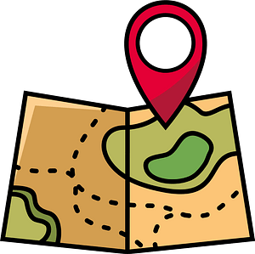  EXPLORING OUR WORLD & BEYOND OUR LOCAL AREA  (TRIPS & VISITS TO PLACES OF WORSHIP) | TIME TO SHINE  (TAKE PART IN A PERFORMANCE) | IT’S ART!  (WATCH A PERFORMANCE; WORK WITH AN ARTIST; VIEW ART) | IN IT TO WIN IT  (ENTER A COMPETITION) | ENTERPRISE & THE WORLD OF WORK  (UNDSTG MONEY MANAGEMENT & ENTERPRISE PROJECTS) | NURTURE & RESPONSIBILITY (SENSE OF RESP FOR SELVES & WHERE THEY LIVE- EG CARE FOR A PLANT/S, ANIMALS) | HELPING HAND  (SERVING SCHOOL & WIDER COMMUNITY- EG SCHOOL COUNCIL, MONITORS, PREFECTS, LITTER PICKS ETC)
NURSERY | Visits to St Clements Church  Welly walk around school ground  Trip to the local park  Transport survey  Trip to a farm  Minibeast workshop | Nativity  End of year performance  Mouse Club  Awards ceremonies | Artist in residence session  Watching Christmas pantomime & KS1 Nativity  Watching Drama club performance | Christmas hat parade  Easter bonnet competition | Welly walk- sponsorship  Non uniform fundraising  Macmillan coffee morning | E-safety  Road & water Safety  Planting cress  Lifecycles  Feeding birds  Healthy Lifestyle Week | Visiting the elderly  Donating uniform  Being a classroom monitor  Litter Picking & recycling
RECEPTION | Visits to St Clements Church- one trip to look around and for church services e.g. Christmas, Easter, Reception Welcome Service etc  Autumn welly walk around local park.  Trip to a Castle | Nativity  Class assembly- Summer 2  Awards ceremonies | Artist in residence session  Watching Christmas pantomime & KS1 Nativity  Watching Drama club performance | Christmas hat parade  Easter bonnet competition | CLEMS points- learning that if they save their points they will get better prizes  Welly walk- sponsorship  Non uniform fundraising  Macmillan coffee morning  People Who Help Us- world of work | E-safety  Road & water Safety  Growing plants in class  Lifecycles  Minibeast workshop | Visiting the elderly  Helping to tidy after Nursery stay and play  Donating uniform  Being a classroom monitor  Litter Picking & recycling

