Pupil premium strategy statement 2023-24

This statement details our school’s use of pupil premium funding to help improve the attainment of our disadvantaged pupils.

It outlines our pupil premium strategy, how we intend to spend the funding in this academic year and the effect that last year’s spending of pupil premium had within our school.

School overview
Detail | Data
School name | St Clements C of E Primary
Number of pupils in school | 217 with 26 Nsy expected
Proportion (%) of pupil premium eligible pupils | 54.4% no Nsy
Academic year/years that our current pupil premium strategy plan covers (3 year plans are recommended) | 2023-2024  2024-2025
Date this statement was published | 19th September 2023
Date on which it will be reviewed | July 2024
Statement authorised by | Eleanor Ward- Chair of Governors
Pupil premium lead | Jane Parker- Head Teacher
Governor lead | Tony Daly- PPG link governor
Funding overview
Detail | Amount
Pupil premium funding allocation this academic year | £3,711.00 EYFS (01 Sept - 31 March)  £TBC EYFS (01 Apr -  31 Aug)  £101,850.00 R - Yr6 (01 Sept - 31 March)  £TBC R - Yr6 (01 Apr -  31 Aug)
Recovery premium funding allocation this academic year | £8,773.00 (01 Sept - 31 March)  £TBC - (01 Apr -  31 Aug)
Pupil premium funding carried forward from previous years (enter £0 if not applicable) | £8,787.00 – this was due to receiving additional grants
Total budget for this academic year | £105,561.00 (01 Sept - 31 March)  £TBC (01 Apr -  31 Aug)  £8,773.00 (01 Sept - 31 March)  £TBC - (01 Apr -  31 Aug)  £8,787.00 bought forward

Part A: Pupil premium strategy plan

Statement of intent
Our intention is that all pupils, irrespective of their background or the challenges they face, make good progress and the majority achieve age related or higher attainment across all subject areas. The focus of our pupil premium strategy is to support disadvantaged pupils to achieve that goal, diminishing the difference between their non-disadvantaged peers, including progress for those who are already high attainers.
We are aware of the challenges faced by vulnerable pupils and their families, such as those who have a social worker or are living in deprivation. The activity we have outlined in this statement is also intended to support their needs, regardless of whether they are disadvantaged or not.
Quality first teaching is at the heart of our approach, with a focus on areas in which disadvantaged pupils require the most support. This is proven to have the greatest impact on closing the disadvantage attainment gap and at the same time will benefit the non-disadvantaged pupils in our school. Implicit in the intended outcomes detailed below, is the intention that non-disadvantaged pupils’ attainment will be sustained and improved alongside progress for their disadvantaged peers.
Our strategy is also integral to wider school plans for education recovery, notably in its targeted support for pupils whose education has been worst affected, including non-disadvantaged pupils.
Our approach will be responsive to common challenges and individual needs, rooted in findings from assessment, not assumptions about the impact of disadvantage. The approaches we have adopted complement each other to help pupils excel. To ensure they are effective we will:
- ensure disadvantaged pupils are challenged in the work that they’re set
- act early to intervene at the point need is identified
- adopt a whole school approach in which all staff take responsibility for disadvantaged pupils’ outcomes and raise expectations of what they can achieve

Challenges

This details the key challenges to achievement that we have identified among our disadvantaged pupils.
Challenge number | Detail of challenge
1 | The majority of pupils enter our nursery with communication and language needs, impacting on their ability to speak and understand which in turn delays their ability to read and write.
2 | The ability to write to a standard similar to other pupils of the same age, is difficult for the vast majority of our pupils.
3 | In some classes and subjects, the gap between disadvantaged and non disadvantaged pupils is wide. If this continues, it will impact on their outcomes at the end of Key Stage 1 & 2 and into Key Stage 2 & 3.
4 | Lack of awareness of some parent/carers regarding the importance of working in partnership with school and how to support their child’s learning.
5 | Persistent absence for some disadvantaged pupils has increased compared to their non-disadvantaged peers during the last academic year. Our assessments and observations indicate that absenteeism is negatively impacting disadvantaged pupils’ progress.
6 | Pupils with specific social and emotional needs which affect their learning due to a lack of focus, low self esteem and minimal coping strategies.

Intended outcomes
This explains the outcomes we are aiming for by the end of our current strategy plan, and how we will measure whether they have been achieved.
Intended outcome | Success criteria
Improved oral language skills and vocabulary among disadvantaged pupils. | - Improved understanding of pupils SALT needs  - Improvement in SALT outcomes- e.g. increased levels in key word understanding, speech sound articulation & progress from initial to exit screening.  - Impact on pupil’s abilities to read and write- if they can articulate sounds, they will then be able to say words to support their reading and writing skills.
Improved writing attainment among disadvantaged pupils | - Teacher’s skills will be improved in teaching and assessing writing  - Through the use of quality written feedback by adults at the point of learning or after a lesson that pupils are expected to respond to.  - Increased progress and % of pupils at age related expectations in writing increases.
Attainment gap between disadvantaged and non-disadvantaged pupils narrows in certain subjects and classes | - As the academic year goes on, termly data and pupil progress meetings, show that the gap is narrowing in the classes and subjects identified.  - By the end of the academic year, the attainment in the focus subject in those classes has increased so that the gap between disadvantaged and non-disadvantaged pupils has narrowed or it has surpassed the attainment of non-disadvantaged pupils.
Increase in parent/carer involvement in their child’s learning and their own understanding of how to support their child/ren | - Parent/carers are more able to support their child’s learning at home  - Increased rates of progress & % of pupils at age related expectations (ARE)
To achieve and sustain improved attendance for all pupils, particularly our disadvantaged pupils. | - The percentage of all pupils who are persistently absent is no more than 10% and the figure among disadvantaged pupils being no more than 12%
Pupils and families are applying strategies learnt during 1:1 or group sessions to result in a reduction in emotional outbursts both at home and school | - To provide dedicated time and support to pupils (1:1 and group)  - To improve the self esteem, social skills and behaviour of identified pupils leading to increased confidence and attainment in the classroom (use of Boxall Profile as a measure as well as attainment & progress data)  - To provide support to parent/carers in understanding their child’s needs and to improve relationships and routines at home.

Activity in this academic year
This details how we intend to spend our pupil premium this academic year to address the challenges listed above.

Teaching (for example, CPD, recruitment and retention)
Budgeted cost: £11,500.00
SALT meetings - £1,500.00
Coaching - £2,000.00
Implementation of our Presentation, Marking & Feedback Policy - £2,000.00
Speaking & Listening Project Staff Meeting preparation & time for English Leads £2,000.00
Zones of Regulations Training - £2,000.00
Team Teach level 2 Refresher training for certain staff Feb 24 - £2,000.00

Activity | Evidence that supports this approach | Challenge number(s) addressed
Increase knwldg and undstg of Speech & language issues with all staff & parent/carers via training sessions & meetings | Oral language interventions can have a positive impact on pupils’ language skills. Approaches that focus on speaking, listening and a combination of the two show positive impacts on attainment:  Oral language interventions | EEF (educationendowmentfoundation.org.uk) | 1, 2, 3, 4 & 6
Implementation of a coaching approach with teachers and teaching assistants to further develop the Write Stuff Approach (our Writing curriculum) in school | Sharing good practice across a school that uses the same teaching approach in a curriculum area, has been proven to develop knowledge, skills and approaches  Effective Professional Development EEF  https://educationendowmentfoundation.org.uk/education-evidence/guidance-reports/effective-professional-development | 2 & 3
Embedding our Presentation, Marking & Feedback policy to ensure written comments and marking are acted upon by supporting pupils to focus future learning on areas of weakness, through identifying and explaining misconceptions, through supporting them in taking greater responsibility for their own improvement or through increasing pupils’ motivation to improve. | There is evidence to suggest that feedback involving metacognitive and self-regulatory approaches may have a greater impact on disadvantaged pupils and lower prior attainers than other pupils. Pupils require clear and actionable feedback to employ metacognitive strategies as they learn, as this information informs their understanding of their specific strengths and areas for improvement, thereby indicating which learning strategies have been effective for them in previously completed work.  Teacher Feedback to Improve Pupil Learning EEF  https://educationendowmentfoundation.org.uk/education-evidence/guidance-reports/feedback | 2 & 3
Provide CPD to class based staff to refresh their knowledge on the importance of being good speaking & listening role models. Also, to introduce approaches that develop pupil’s speaking & listening skills. | Sharing good practice across a school that uses the same teaching approach in a curriculum area, has been proven to develop knowledge, skills and approaches  Effective Professional Development EEF  https://educationendowmentfoundation.org.uk/education-evidence/guidance-reports/effective-professional-development | 1 & 2
Continuation of whole or 1:1 staff training on behaviour management and anti-bullying approaches via the Zones of Regulation materials with the aim of developing our school ethos and improving behaviour across school. | Both targeted interventions and universal approaches can have positive overall effects:  Behaviour interventions | EEF (educationendowmentfoundation.org.uk) | 6

Targeted academic support (for example, tutoring, one-to-one support structured interventions)
Budgeted cost: £42,540.00
SALT (1yr) - £9,165.00
SALT TA (½ salary for 1yr) – £16,325.00
Other SALT interventions - £3,300.00
Class based staff booster group/1:1 intervention - £5,250.00
Parent’s meetings & Resources - £3,500.00
Computing Subscriptions - £5,000.00

Activity | Evidence that supports this approach | Challenge number(s) addressed
Commissioning of a qualified Speech and Language therapist (SALT) for 1 day per week to assess pupils, implement SALT programmes (weekly meetings with SALT TA who implements below) | Oral language interventions can have a positive impact on pupils’ language skills. Approaches that focus on speaking, listening and a combination of the two show positive impacts on attainment:  Oral language interventions | EEF (educationendowmentfoundation.org.uk) | 1, 2, 3 & 6
Implementation of programmes and individual communication plans to improve listening, narrative and vocabulary skills for disadvantaged pupils who have relatively low spoken language skills. | Oral language interventions can have a positive impact on pupils’ language skills. Approaches that focus on speaking, listening and a combination of the two show positive impacts on attainment:  Oral language interventions | EEF (educationendowmentfoundation.org.uk) | 1, 2
Use of class based staff to work with pupils in a group or on a 1:1 basis for a limited amount of time in a specific subject that data shows disadvantaged pupils are attaining lower than their non-disadvantaged peers in | Tuition targeted at specific needs and knowledge gaps can be an effective method to support low attaining pupils or those falling behind, both one-to-one:  One to one tuition | EEF (educationendowmentfoundation.org.uk)  And in small groups:  Small group tuition | Toolkit Strand | Education Endowment Foundation | EEF | 3
Delivery of 1:1 or group meetings/sessions with parent/carers to increase their awareness of where their child/ren are at in their learning and providing them with additional support & activities to progress their child/ren further | Parents play a crucial role in supporting their children’s learning, and levels of  parental engagement are consistently  associated with better academic outcomes.  Evidence suggests that effective parental engagement can lead to learning gains of +3 months over the course of a year.  Working with Parents to Support their  Children’s Learning  https://educationendowmentfoundation.org.uk/education-evidence/guidance-reports/supporting-parents | 4
Use of technology to provide targeted educational support to supplement quality first teaching- eg subscription to Splingo, IDL literacy, Times Tables Rockstars | Using technology in ways which support improved teaching or improved pupil learning (e.g. by increasing the quality and quantity of pupil practice).  Using Digital Technology to Improve  Learning  https://educationendowmentfoundation.org.uk/education-evidence/guidance-reports/digital | 1, 2, 3 & 4

Wider strategies (for example, related to attendance, behaviour, wellbeing)
Budgeted cost: £91,047.00
Parental Support £18,749.00
Attendance Officer £20,435.00
Learning Mentor & Parental Support £24,878.00
Social Worker £26,685.00
Attendance Rewards - £300.00

Activity | Evidence that supports this approach | Challenge number(s) addressed
Commissioning of a social worker based in school for 3 days per week & 6 days out of term time Sept 23-March 24 | We are hoping that by continuing to employ a school based social worker, it will increase capacity not only for our families who will be signposted to agencies that can support them but also, increase capacity for the 5 other designated persons for child protection in school who also have other roles. | 4, 5 & 6
Release time for the attendance support officer and social worker to develop and implement new procedures to improve attendance. | The DfE guidance has been informed by engagement with schools that have significantly reduced levels of absence and persistent absence.  DfE’s Working Together to Improve School Attendance Guidance | 5
Dedicated time and support to pupils (1:1 and group) to improve the self esteem, social skills and behaviour of identified pupils leading to increased confidence and attainment in the classroom. Also, to provide support to parent/carers in understanding their child’s needs and to improve relationships and routines at home. | By Improving Social and Emotional Learning in Primary Schools it increases the resilience and independence of pupils and families. It is especially important for children from disadvantaged backgrounds and other vulnerable groups, who, on average, have weaker SEL skills at all ages than their non-disadvantaged classmates.  Improving Social & Emotional Learning in Primary Schools EEF  https://educationendowmentfoundation.org.uk/education-evidence/guidance-reports/primary-sel | 4 & 6
Total budgeted cost: £145,087

Part B: Review of outcomes in the previous academic year

Pupil premium strategy outcomes
This details the impact that our pupil premium activity had on pupils in the 2022-23 academic year.
DISADVANTAGED PUPIL DATA (JULY 23)
SCHOOL FSM ELIGIBLE: 133 pupils = 56.8%

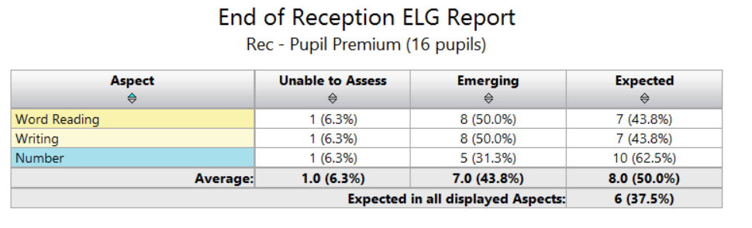
-More FSM pupils achieved the Early Learning Goal in W & M than NFSM pupils
Y1 PHONICS:
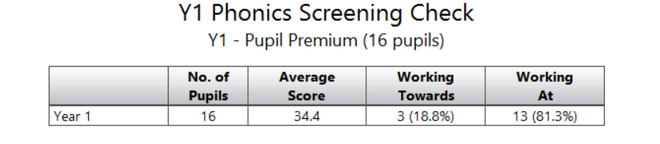
13/16 PPG eligible pupils passed the phonics screening check. Their average score was 34 (pass mark 32) higher than their NPPG peers who performed worse on the phonics screening check with an average score of 29 and only 8/15 passing the phonics screening check.

KS1: % ACHIEVING EXPECTED STANDARD
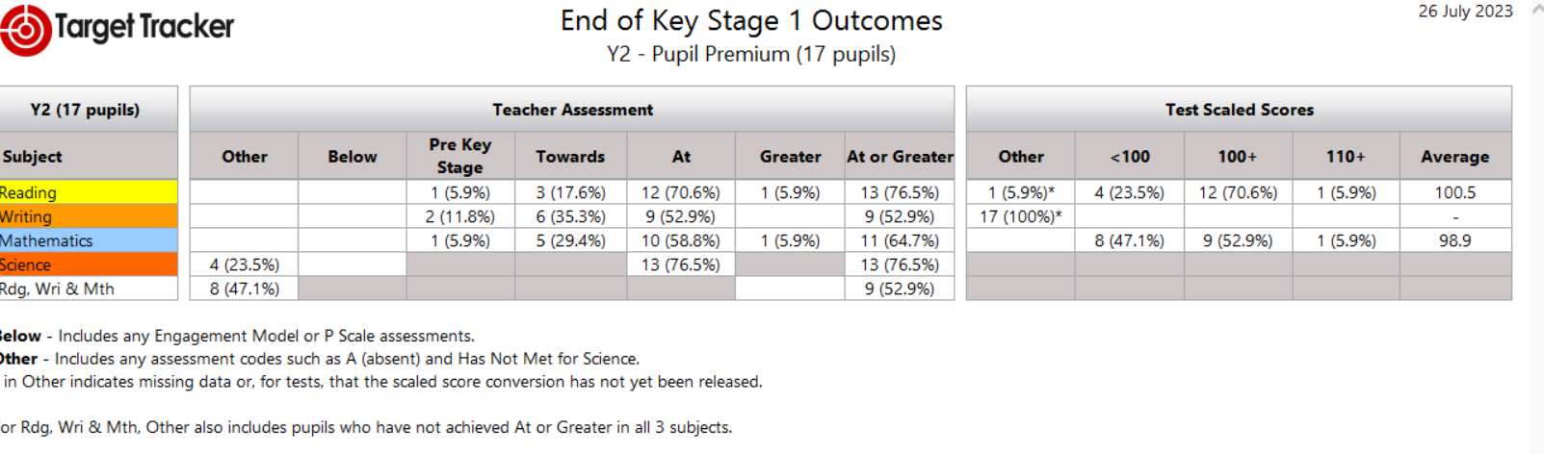
PPG pupils are attaining at a higher standard than their NPPG peers at the expected standard in Reading, Maths and Science. However, not as many PPG eligible pupils are attaining at greater depth and this reduces their average point score.

KS2: % ACHIEVING EXPECTED STANDARD
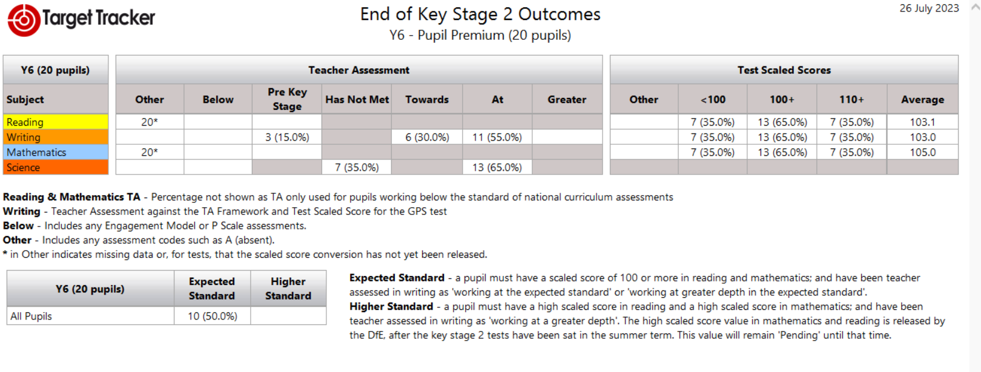
-Looking at the Test Scaled Scores, more PPG pupils achieved at the expected or higher standard than NPPG pupils. However, their average point score is not as high due to more PPG pupils not reaching the expected standard (NB Writing on the test scaled scores refers to the SPAG test). Writing was teacher assessed and again, more PPG pupils achieved the expected standard in comparison to NPPG pupils.
-More PPG pupils achieved the expected standard in the combined subjects- R, W & M (10) than NPPG pupils (4)

Externally provided programmes
Programme | Provider
Lancashire Phonics Catch Up Intervention | Lancashire County Council
Unlocking Letters & Sounds | Ransom
IDL Literacy (online reading and spelling intervention) | IDL Solutions

Service pupil premium funding (optional) N/A
Measure | Details
How did you spend your service pupil premium allocation last academic year?
What was the impact of that spending on service pupil premium eligible pupils?

Further information (optional)
- The success of the individual pupil premium interventions that lie beneath the activities noted above are described in detail on our Blue Hills Provision map. Staff who deliver the intervention/s are expected to set baseline and exit outcomes as well as completing evaluations after each session. This is overseen by the PPG lead, who regularly reviews the frequency of intervention delivery and the quality of the written evaluations. The provision map also costs each intervention so we can evaluate impact versus cost to determine if the intervention is worth repeating or a different approach is needed.
- Children Looked After or Previously Looked After also have their own funding cost centres and reports. Although many of them take part in the interventions listed in this statement, their parent/carers are contacted at least twice a year to inform them of what was spent and the impact of this expenditure in the previous academic year and to also ask them what they would like to purchase to support their child. Requests have included electronic devices to support home learning and payment for extra curricular activities such as swimming lessons.
- St Clements has been identified to receive targeted support from the Local Authority due to having Good Level of Development outcomes that are below 50% for the last two years and being in an area that has high levels of deprivation. The Pathfinder Project (starting in September 23- July 24) aims to provide groups of schools with access to Educational Psychology, SALT, Early Help and Family Outreach worker services to develop staff skills and increase parental capacity. The project starts with a focus on the new Year 2 cohort due to the impact the COVID 19 pandemic had on their early experiences. The project can then focus on the new Year 1 and Reception classes if there is time and a need in the school.
- St Clements have been fortunate to again be awarded £20,000 from the Forgotten Forty (F40) Foundation in 2023-24 for a third year -sponsored by INEOS. This is due to the high percentage of pupils in receipt of a FSM in school. In 23-24, we intend to spend the award on financing educational visits and visitors to bring our curriculum to life and provide our pupils with experiences outside of their immediate locality that a number of them would not experience. Also, to develop our focus on the Arts through teaching pupils to play a different instrument and working with an artist to extend our pupil’s understanding of a different medium in Art.
- Three members of staff are about to complete their fully funded National Professional Qualifications (NPQs) in Autumn 23, one is continuing until Summer 24 and another member of staff is starting their NPQ in Autumn 23. This shows the dedication of staff to continue to professionally develop and keep abreast with current developments to impact on their practice in school.

