
“Growing together to let our light shine”
St Clement’s C of E Primary School Monthly Newsletter: February 2024
Welcome to February’s Newsletter!
Dates for your Diary:
-Monday 26th February 8.45/8.50am- Start of Spring 2 Half Term
-Monday 26th February All Day- Y6 Artist in Residence
-Tuesday 27th February AM- Reception and PM Nursery Artist in Residence
-Tuesday 5th March PM- New Nursery Sept 2024 Stay and Play session in the hall
-Wednesday 6th March- Y4 Greek Food Experience Day
-Wednesday 6th March All Day- Nursery trip to Smithills Farm
-Wednesday 6th March 2.40pm- Parent/Carer forum in the hall
-Thursday 7th March- World Book Day and Themed Lunch
-Thursday 7th March- 9am-10.10am Year 6 Parent/carer session
-Thursday 7th March 2.45pm- Y3 Parent/carers invited in to look at Humanities work
-Friday 8th March- Mother’s Day Gift Event
-Friday 8th March 2pm- Y2 Fire Brigade session
-WB 11th March SCIENCE WEEK- ‘Time’ Theme
-Tuesday 12th March PM- New Nursery Sept 2024 Stay and Play session in the hall
-Wednesday 13th March- Y5 African Instruments Experience Day
-Thursday 14th March 8.45am- Nursery and Reception Story & toast morning
-Friday 15th March PM- Y5&Y6 Football Match at Denton Youth
-Tuesday 19th March 4pm- Drama Club Performance- ‘The Little Mermaid’
-Thursday 21st March- Reception Experience Day Growing/printing
-Thursday 21st March- Y3 Experience Afternoon
-Thursday 21st March 2.10-3.10pm- Y5 Parent/carer session
-Thursday 21st March- EPIC Afternoon Tea
-Friday 22nd March- End of Term Awards
-Friday 22nd March- Top Table for Spring 2
-WB 25th March- Bikeability all week for Year 5
-Monday 25th March AM- Y6 Girls Football tournament
-Tuesday 26th March PM- New Nursery Sept 24 Stay and Play session in the hall
-Tuesday 26th and Wednesday 27th March- Parent/Carer meetings after school
-Wednesday 27th March- End of Term Awards
-Thursday 28th March- Whole School ETHOS Day
-Thursday 28th March 9.15am- Easter Church Service
-Thursday 28th March 3.15pm- End of Spring Term


End of Half Term Values Award- Compassion and Love were our Christian Values that we learnt more about this half term. We also looked out for pupils and families demonstrating this in their day to day lives and celebrated them at our Values Award Worship. Thanks for setting a great example and for living out our school values in your day to day lives.


EPIC Afternoon Tea- Ronan, Jayden, Esther, Aliyana, Imran and Abdullah A were invited to Afternoon Tea to celebrate them being awarded the EPIC Award for showing high Expectations, Positivity, being an Inspiration and showing Creativity. Well done to all of you for achieving the highest award in school.

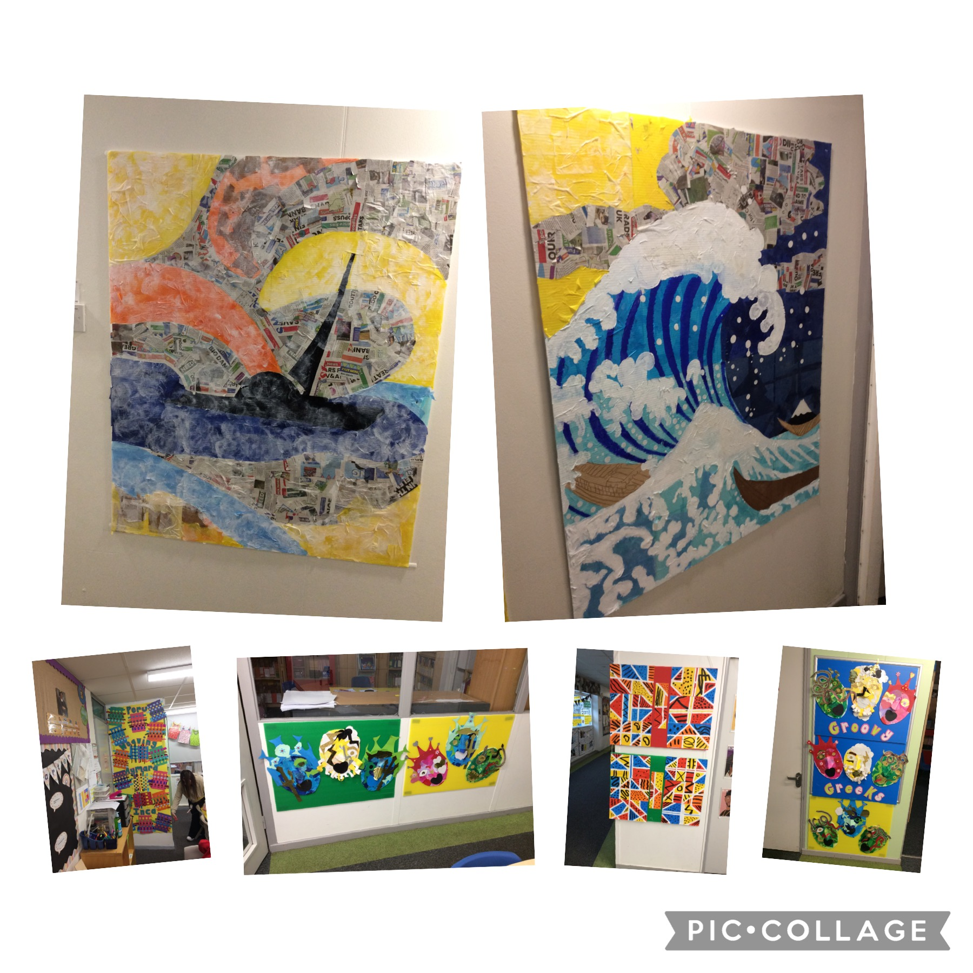

Artist in Residence Sessions- Thanks to the ongoing, generous funding to our school from the Forgotten 40 Foundation and INEOS, we have again been able to provide our children with the opportunity to work with an artist in school. This year, the artist has focussed on developing that children’s skills and understanding of collage and 3D materials. As a result, we now have some eye catching and amazing pieces of art on display around school. Thanks to Miss Beedle for organising these sessions.

Safer Internet Day- On 6th February 2024, St Clements joined in the national Safer Internet Day to promote safe behaviour when using the internet. The day began with class sessions that parent/carers were invited in to and we were really impressed by the number of parent/carers who attended in our Nursery, Reception and Year 3 classes. During the day, each class learnt more about an aspect of online safety through stories, video clips and interesting activities. Thanks to Mr Nield for arranging the day’s events.
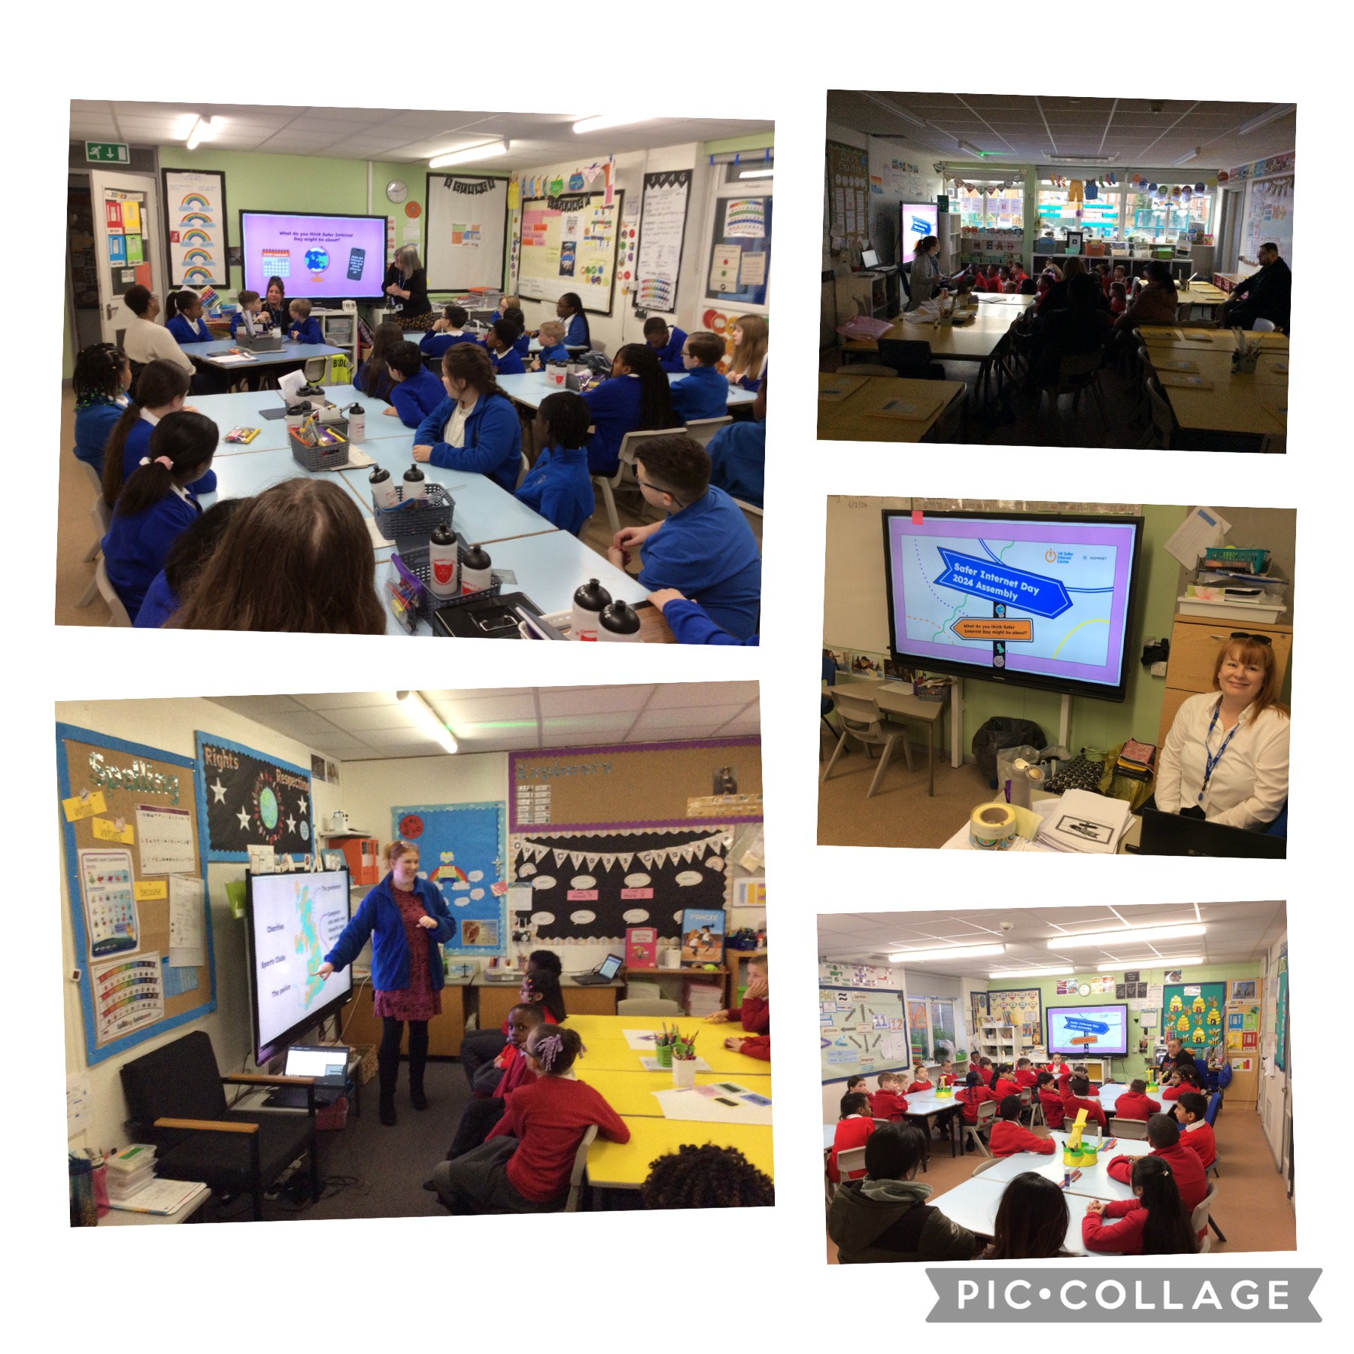

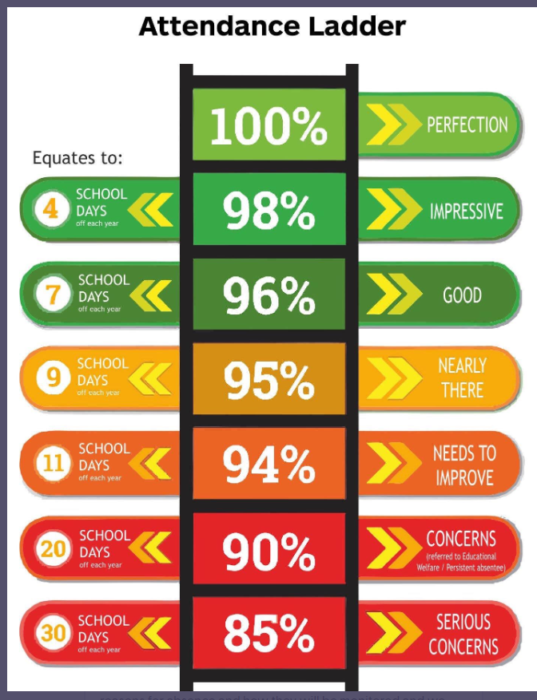
Attendance Matters- At the end of the Autumn Term, 64 pupils had attendance of below 90%. This is over a quarter of our school who are classed as persistent absentees.

As a result, the parent/carers of each of these 64 pupils have been sent a letter to inform them of their child’s attendance, the reason for absence and how they will be monitored and we expect to see this increase over this term. It also outlines the ways we can help and support parent/carers to do this and I had a really good meeting with one parent yesterday that has now led to us setting up more things to help her and her children going forwards.
Failure to increase their child’s attendance and if parent/carers refuse to engage with the support school can offer, will lead to referrals to other agencies or penalty notices (fines) from the local authority.
A reminder that we are always willing to support and engage with parent/carers so we can ensure our children have the best possible start in life.

