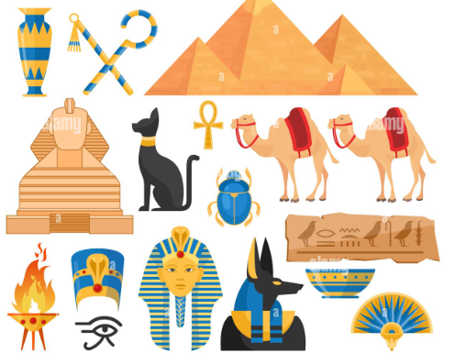

**Year 3 Curriculum:** **Summer 2024**

**The Wonderful World of Ancient Egypt gyptians**

**History:**

In History we’ll be looking at the Culture and Beliefs of the Ancient Egyptians.

We’ll be comparing our ways of life with theirs and will develop our historical vocabulary.

We’ll also be looking at a variety of sources to learn as much as we can about this culture.

**PE:**

We will continue to develop skills in fitness and balance in our Fitness sessions. We will be practicing dance and Gymnastics.

-

**Computing:**

Presentation skills:

Word Processing and Powerpoint presentations!

**Art /DT** We will:

Be examining Hieroglyphics and Egyptian Art, including Clay work and Pyramid building!

In DT, We’ll be looking at Ancient Egyptian cooking and making our own Egyptian meals.

**Music:** In Music we will be using percussion and IT to portray the Human Body, as well as understanding how we can communicate using music!

**Drama Opportunities:**

Egyptian Cinderella/ Gods and Goddesses of the Nile

Hot seating astronauts

**Writing Opportunities:**

We will continue to develop our writing skills by creating a descriptive piece including description of character and setting. We’ll conclude our work with an information text.

**RE:**

What does it mean to be a Christian in Britain today?

**PSHE:**

Keeping Safe and RSE

British Values – Individual Liberty and Rule of Law

**Numeracy Links:**

In Maths we will be working on the following:

Time, Statistics, Fractions, Angles and Shapes including perimeter.

We will also continue to work on our key arithmetic skills.

**Science:**  **Food and our bodies**

Forces, including Magnetism

**French:** Songs/Questions