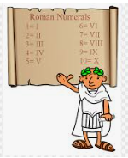

**Questions children want to investigate:**

* When was the Roman Empire at its height?
* What was life like in Roman Times?
* Where did people live in the Roman Era?
* Which Gods did the Romans worship?
* What made the Romans such efficient fighters and invaders?
* What did the Romans eat?
* Were the Romans like the Greeks?

**RE:**

Aut 1: Jesus the Teacher

Aut 2: Christmas Around the World

**PSCHEE**

Mental and Emotional Health

**PE and Music:**

**PE:** Net Games- Accuracy and Rallies

Invasion Games – Invasion in a Team (Hockey and Ball skills)

**Music:** Keeping Healthy

Our Community

**Autumn term 2024 Year 5**

**Roman Life**

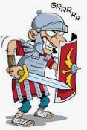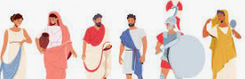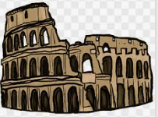

**Science:**

**Materials Y5**

Following on from their Y4 unit on Solids, Liquids and Gases, the children will experience a range of reversible and irreversible changes.

We will continue to focus on Working Scientifically by planning and carrying out our own investigations, collecting data and explaining our discoveries using scientific vocabulary.

**Writing Opportunities:**

We will continue to write every day, building up effective vocabulary by writing stories and poems as well as non – fiction linked to our Roman topic.

**Drama Opportunities:**

Hotseating, Roleplay,

**Stories/Texts/links:**

The Promise

Can We Save the Tiger?

The Man Who Walked Between the Towers

**Art /DT:**

* Exploring the Romans’ use of mosaic, using these techniques to make mosaic artwork
* Design a healthy Italian menu, follow recipes, taste Italian food

**Numeracy Links:**

* Place Value
* Four Operations
* Roman Numerals
* Statistics for science

**Computing:**

**Code I.T. - *Coding and Programming - Game Design***

* design, write and debug programs by breaking them into smaller parts.
* use sequence, selection and repetition in programmes.
* work with variables and various forms of input and output.
* use logical reasoning to explain how some simple algorithms work.
* detect and correct errors in algorithms and programmes.
* Design and evaluate a game using Scratch.

Curriculum links:

Discreet Subject

**Geography Focus:**

Geography will focus on the Roman Empire and its expansion throughout Europe, Asia and Africa.

We will compare the UK with Italy.

We will place the Celtic tribes on maps of the UK

**History Focus:**

Life in Roman times

The legacy of the Romans in Britain

Roman Gods and worship

Roman invaders

Comparing Ancient Rome and Ancient Greece