Year 4 Topic: Vicious Vikings
Autumn Term 2024
Questions children want to investigate:

Where were Vikings from?
What do they do?
Were they dangerous? Why?
Why did they go to new countries?
What weapons did they have?
What was Viking life like?

Art / Design & Technology:
We will focus on drawing techniques such as hatching, shading, dotting to produce pictures of Viking artefacts such as knots, shields and helmets.
We will experiment with carving and relief to produce Viking patterns
In DT we will explore moving picture books and design and make our own book for a younger child.

Humanities: Vicious Vikings

Meet the Vikings: we are going to find out where the Viking homelands were and what life was like there. We will explore Viking ‘jobs’, names and foods and what it took to become a Viking leader.

We will also investigate the Vikings as they travelled to other countries: the plotting of invasions; making and sailing longboats; and the raiding and pillaging of the Viking warriors.

Finally, we will look at the Viking and Anglo-Saxon struggle for the Kingdom of England.

In Geography we will focus on settlements, investigating the physical and human features of a good settlement and exploring how and why the Vikings settled where they did.
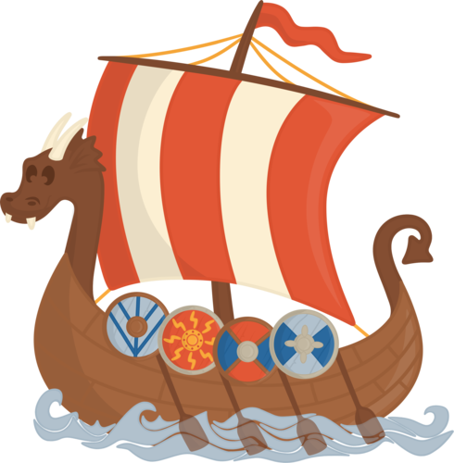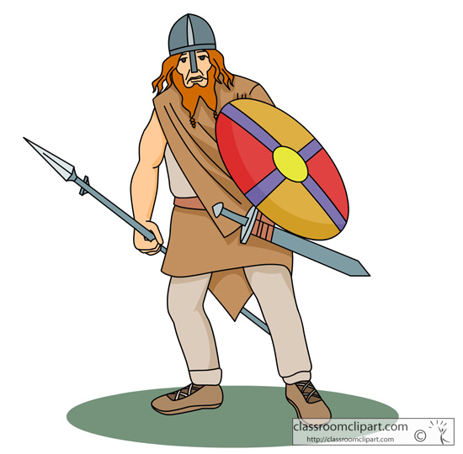

Computing: Data Logging / Coding

Children will learn how to use a data logger for recording different information – they will present their data in different ways using a variety of programmes.
PE and Music:
Every week the children will be taken to the pool to learn and practise their swimming. They will also have an extra PE lesson in school with our coach.
Music: Group ensemble performance

PSHCEE:
Mental and emotional health – resilience, choices and discrimination.

Healthy lifestyles - healthy fuel, sleep and being ill.

British Values - Democracy

Maths: Maths – No Problem!

Children will develop their understanding of number and place value, including counting in multiples, comparing numbers and rounding.

Children will add and subtract numbers to 10,000, using mental and formal methods.

Writing Opportunities:
Stories set in the times of the Vikings to show Viking life. Non-chronological reports and fact-files about Viking life.

French:
French phonics and pronunciation.
I am learning to talk about animals in French.

Science:
Autumn 1: Sound and Hearing
We will be learning about how sounds are made, how we can change pitch and volume and how our ears process sound.
Autumn 2: Electricity
We will be learning about the uses of electricity and how to make a working circuit.
Visits:
We will welcome a
Viking Visitor to school in Autumn term.

RE: Why do some people think life is a journey? What significant experiences mark this?

