**Art /DT:**

**DT-** Children will investigate a variety of different vehicles before undertaking the fun task of designing, making and evaluating their own vehicle. They will learn all about wheels, axles and chassis and how they are combined to make the framework of the vehicle, as well as how to create an eye-catching body.

**Art –** To be able to know and understand what clay is.

-Where does clay come from and how is it made?

-To know what a print is and who/what makes these prints

-To know basic shapes and colours to help identify prints.

**ICT: Coding**

Children will be able to:

• Use different end blocks, including repeat forever;

• Change the size of characters to grow or shrink.

• Hide and show characters with an instruction block;

• Program two or more characters with

instructions at the same time.

**Humanities:**

**History – To** know about significant events in the lives of explorers from a range of different era e.g. Christopher Columbus, and Neil Armstrong.

**Geography – Map Makers**

Children will find out what maps are and some of the different ways they are used. They will learn about the four compass points and use these to navigate around maps.

**Topic: Explorers**

**Year 2 - Autumn 2024**

**Writing Opportunities:**

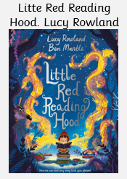

-Narative with an alernative ending.

-Character discription.

-Inner thought.

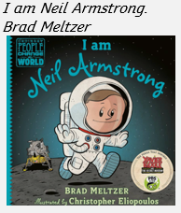

-Fact file

**Stories/Texts/links:**

Narrative: Imaginative Stories -Information Text Poetry, Recount of trip Instructions (linked with DT)

**Science:**

**Materials** -Identify and compare the suitability of a variety of everyday materials, including wood, metal, plastic, glass, brick, rock, paper and cardboard for particular uses

-Describe how the shapes of solid objects made from some materials can be changed by squashing, bending, twisting and stretching.

**Animals including Humans**- Living things need light, air and water to stay alive.

- Living things grow and change as they get older.

- All animals move, feed, grow, use their senses and reproduce.

- We need food to give us energy. We need food to grow. We need food to keep us healthy.

**Numeracy :**

Number and Place Value: Numbers to 10

Calculations: Addition and Subtraction

Calculations: Multiplication of 2, 5 and 10

Calculations: Multiplication and Division of 2, 5 and 10

Measurement: Length

Measurement: Mass

**PE and Music:**

Net Games – Striking for Accuracy

Invasion Games – Sending and receiving **Music: Music Express –** Ourselves,

Travel, Toys and Number

**RE:** Who is a Muslim and what do they believe? This investigation enables pupils to learn in depth from Islam, finding out about Muslim ways of life and beliefs, so that pupils can develop thoughtful ideas and viewpoints of their own about some religious and spiritual questions.