serving Jesus

**Topic: Year 1 All About Me**

**Autumn 1 and 2 - 2024**

**Art /DT:**

**Art –** Studies of portraits and self-portraits, using different media to create images.

Children will access a range of art and design resources independently to make pictures and models.

**DT** – Food Technology

**Questions we will investigate**

What does out heart look like?

What helps us breathe?

What can we do with our toes?

What are our senses and what do they do?

What are the different parts of my body called?

How tall am I? How long are my legs?

Why do leaves fall of the trees in Autumn?

What changes will I see in Winter?

Why is the weather cold in Winter?

**Challenges:**

***Throughout this term the children will be given lots of opportunities to work independently on challenges in our indoor and outdoor classrooms. These will include:***

Water

Sand

Malleable

Creative

Construction

Investigation

Reading, Writing & Maths Challenges



**Writing Opportunities:**

We will be exploring the following:

* Lists, captions and sentences
* No David -Narrative
* Firework – Poetry
* Letter – Non Fiction
* Instructions – Non Fiction

We will explore the above through the write stuff approach.

We will be working on basic skills like capital letters, full stops, fingerspaces and handwriting.

**History**

Autumn 1 - My life so far.

**Geography**

What is geography? This unit is very closely linked with the science topic of seasonal change.

**PE and Music:**

**Dance:** children will be using simple movements to create dances.

**Gym:** Apparatus work

**Music:** Music Express

**Maths**

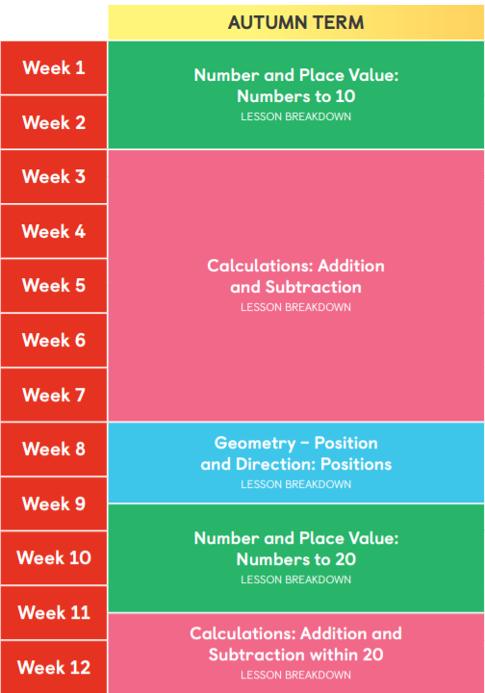

**ICT:** Coding

**RE:-** Harvest

* 1. **Who is a Christian and what do they believe?**

**I Matter Scheme of Work**

**Science:** What is science? Humans: -Identify, name, draw and label the basic parts of the human body and say which part of the body is associated with each sense. Seasonal Change – Autumn