**Humanities: Comparing UK with South America Geography Focus**

Children will be focusing on the geographical similarities and differences of human and physical geography within Manchester and South America.

There will be a focus on mapping skills and longitude and latitude as well as weather, biomes, and time zones.

Topic: Spring 2025

Human Planet Year 6

**PE and Music:**

Dance

Gym: Complex Sequences

Music: World unite (music express scheme)

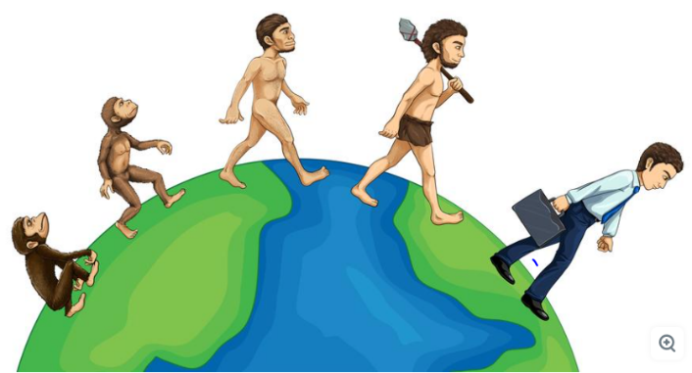

**RE:**

**Using the Manchester scheme of work**

Is it better to express your religion in arts and architecture or in charity and generosity?

**Languages:** The children will learn vocabulary, stories, songs and formulate sentences about being ‘Family, food and the history of Britain’.

**Numeracy Links:**

We will be following the Maths No Problem scheme of work in preparation for the SATS.

Throughout topic lessons children will be exploring measures, ratio and proportion through the recipes in DT.

Children will analyse data and interpret graphs and tables related to the South American topic, especially linked with collecting their own data about weather.

**ICT:**

**Spring 1 - Online safety Unit**

**Spring 2 – Data Handling**

**Science:**

**Evolution and Inheritance**

We will be learning about theories of evolution and inheritance and the work of notable scientists including Darwin.

**Living Things and Their Habitats**

We will be learning how animals can be classified according to their characteristics. We will also be learning about the work of Carl Linnaeus.

**Art /DT:**

**DT** – Focus on South American Food – children will be exploring healthy eating in S.America and will be making empanadas. Children will be looking at where the food sources come from in S.America (geography link with trade).

**Art –** Focus on Graffiti and looking at famous graffiti artists. Children will be designing their own graffiti as well as South American Mola artwork.

**Writing Opportunities:**

**Key Texts:** Cogheart by Peter Bunzl and The **Journey by Francesca Sanna, which is a book about refugees fleeing war.** Children will read these stories and plan narrative writing around the themes in the book.

**Persuasive Speech:** Endangered Animals – children will persuade people to think more about saving the animals and the environment they live in.

**Poetry:** Endangered Animals – exploring what imagery represents these and showing this through words.

**Non fiction:** Writing a factual informative presentation about a specific topic in one of the countries we are studying – Features of S. America and animals linked with Science.

**Drama/S&L Opps:**

Children to share their views about traditions in other countries.

Children to present their findings about specific topics for the countries we are studying.

Giving own views and listening to others views about wealth and poverty.

Debates about Graffiti

Debate about refugees