**Geography: World Weather**

We will use our locational knowledge to locate the cities and countries of Europe and use the 8 points of the compass.

We will study the different weathers that affect the world and their causes and effects.

We will explore why some places have weather that is similar to ours in the UK and why some places have different weather.

We are going to choose a country in Europe to focus on and find out what the weather is like there.

We will learn about extreme weather and the natural disasters that can occur.

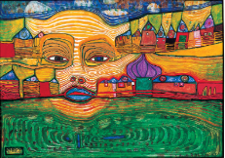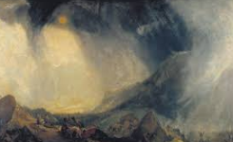

**Year 3 Curriculum:** **Spring 2025**

**World Weather**

**PE:**

We will continue to develop skills in fitness and balance in our Fitness sessions. In our guided PE sessions we’ll be developing our skills in Dance and Gymnastics.

**Computing:**

Online Safety – cyberbullying,

emailing etc.

Databases and creating graphs

**Art -** We will:

Getting in Shape with Hundertwasser. We will explore how the artist used shape and colour to create the vibrant scenes he did. We will continue to develop our own skills using a variety of different materials.

**DT –** We will:

Explore some Stone Age food and evaluate the taste if these. We will also research, design and make a meal that the Stone Age people may have eaten!

**Music:** In Music, we will be looking at music from China and developing our knowledge of music in the past and how it was used to communicate.

**RE:**

Why do people pray? We will be learning why and how Christians celebrate Easter.

**PSHE:**

Living in the Wider World

British Values – Mutual Tolerance & Respect for Diversity

**English: The Artic Animal World…**We will be exploring Artic settings and animals through video clips and books. We will then explore different writing skills to help us write descriptive settings about the artic. We will then be writing information pages about arctic animals we have researched.

**Numeracy Links:**

In Maths, we will continue to work on learning the 3, 4 and 8 times tables. We will be using this knowledge to help us learn more about length, mass and volume.

Later in the term, we will be learning about money and telling the time, including answering reasoning problems based on these.

**Science:**  **Food and our bodies**

Animals including humans: Bones

Biology: Plants

**Languages:** In our French lessons, we will be learning to describe French instruments and have conversations about our talents.

