 serving Jesus 

Year 1 Topic: **Where We Live** (Spring 1 & 2 2025)

**Questions we want to investigate:**

Who was LS Lowry?

What was Manchester like a long time ago?

-

**History:**

LS Lowry

Industrial Manchester and Openshaw

**Geography:**

Our Local Area – Manchester / Openshaw now and in the past.

**Art /DT**

**Art –** learning about the life and work of LS Lowry and producing our own Lowry inspired artwork.

**D.T** – creating a 3D model of a Lowry scene using junk modelling techniques.

**Computing:**  Sort IT (collecting data and making pictograms)

E - Safety

**RE:** How and Why do we Celebrate Special & Sacred Times? (Easter and Id-ul-Fitr)

**PSHE**

We will follow the I matter Scheme

**Numeracy:**

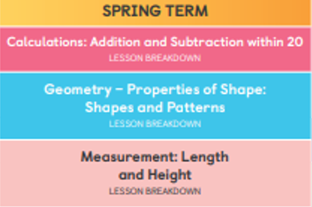

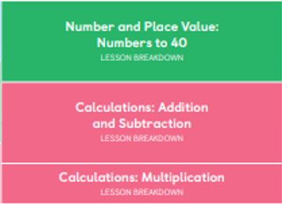

**PE and Music:**

**Dance:** children will be using simple movements to create dances.

**Gym:** Apparatus work

**Music:** Following the Music Express Scheme



**Drama/S&L Opportunities:**

**Role Play:**

**Stories/Texts/links:**

Non – Chronological reports - Bees/LSLowry,

Manchester / Openshaw fact file, Explanations

Rosie Revere Engineer

**Writing Opportunities:**

**Stories** –The Blue Hijab

*Rosie Revere Engineer*

**Non – Fiction** –

Thank you letter

Recount

L.S Lowry fact File

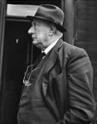

**Science:**

Plants and Growing/Lifecycles

Seasonal Change - Spring