St Clement’s C.of E. Primary School



Handwriting Policy

Reviewed by HSH: January 2025
Approved by JP: January 2025

Review date: January 2026

“With Faith, Hope and Love We Can Achieve Greater Things.”

Vision Statement:
At St Clements, we aim to ensure that everyone thrives within our caring Christian community.
We will use our Christian Values and Bible verse to provide hope during difficult times, gain strength from our faith and ensure love guides us, as an inclusive school family, in all of our actions.

Our Christian Values: (Guiding our Thinking and Behaviour)
Love- (Core Value that all of our 6 Values Flow):
Faith
Hope
Respect
Compassion
Forgiveness
Thankfulness

DDA STATEMENT

At St. Clement’s we will aim to:
- Promote equality of opportunity between disabled people and others.
- Eliminate discrimination that is unlawful under the Act.
- Eliminate harassment of disabled pupils that is related to their disabilities.
- Promote positive attitudes towards disabled people.
- Encourage participation by disabled people in public life.
- Take account of a disables person’s disabilities, even when that involves treating a disabled person more favourably than another person.

Rights Respecting School Link to Articles:
28, 29 & 42

Aims for children:
- To understand the importance of clear, neat presentation in order to communicate meaning clearly.
- To take pride in their presentation of themselves and their work and study handwriting with a sense of achievement.
- To teach the correct letter formation.
- To support the development of correct spelling, by the learning of word patterns and the correct joining of letters.
- To ensure all children are provided with appropriate and achievable goals.
- To write quickly in a neat cursive style by the end of Key Stage 2.
Teaching and learning of handwriting:
We are adopting the Nelson Handwriting style (this can be accessed in teachers only). The style is suggested by Martin Harvey. It is based on a semi-cursive style. It is simplistic, but very clear, and it does not have the ‘loops’ and ‘lead ins’ which feature in some of the more complex handwriting styles.
It is relatively simple to teach and simple for children to learn. It also provides effective teaching strategies and the language of teaching handwriting is used consistently in each year group. Teachers and Teaching Assistants must model the handwriting style well and have high expectations of pupils, so children learn to present their work in a careful, attractive manner.
Children must be taught that good body posture is the key to quality presentation. Children should be taught strategies to support them with their posture:
Two hands – Children should be taught to always use two hands when writing (one hand to hold the paper and one hand to write with).
BBC – Back, bottom and chair and six feet – Four legs of the chair firmly on the floor, and children’s feet on the floor
TNT – Tummy near table.
Paper position - Children should be taught how to hold their pencils and pens correctly and the correct way to place their paper.
Application of the agreed handwriting style:
There will be times when it is not appropriate or manageable for adults and children to use and model the agreed handwriting style e.g. when note taking/quick modelling/quick writing tasks/in certain tests.

We have agreed on three levels of writing:
level 3 being quick writing/note taking (lowest level of handwriting) and

level 2 this is where children work in exercise books. e.g. Skills work in a literacy lesson; exercises on prefixes, suffixes, comprehension work, how to write extended sentences, writing drafts in phase 3 of the Literacy Learning Journey. There should be clear evidence of the school's handwriting style, with finger spaces and correct joins where they have been taught. With this type of task, the high quality of the top level of presentation should not be expected or demanded, but the lowest level of presentation would be totally unacceptable. (middle level of handwriting)

level 1 (highest level of handwriting) where all handwriting skills taught are being applied and children take extreme pride in their writing and present their work at a high standard. It is important that expectations of which level of handwriting style should be applied, are made clear to the children.

Labels on books and signs around the school should be written at level 1 standard, to set an example to pupils.

Worksheets should be typed using the cursive handwriting twinkle font on word, as the formation of the letters is similar to the Nelson handwriting style.

Example of a year 6 pupil’s draft piece of writing compared to the final edited and improved version in their Wonderful Writing Book:

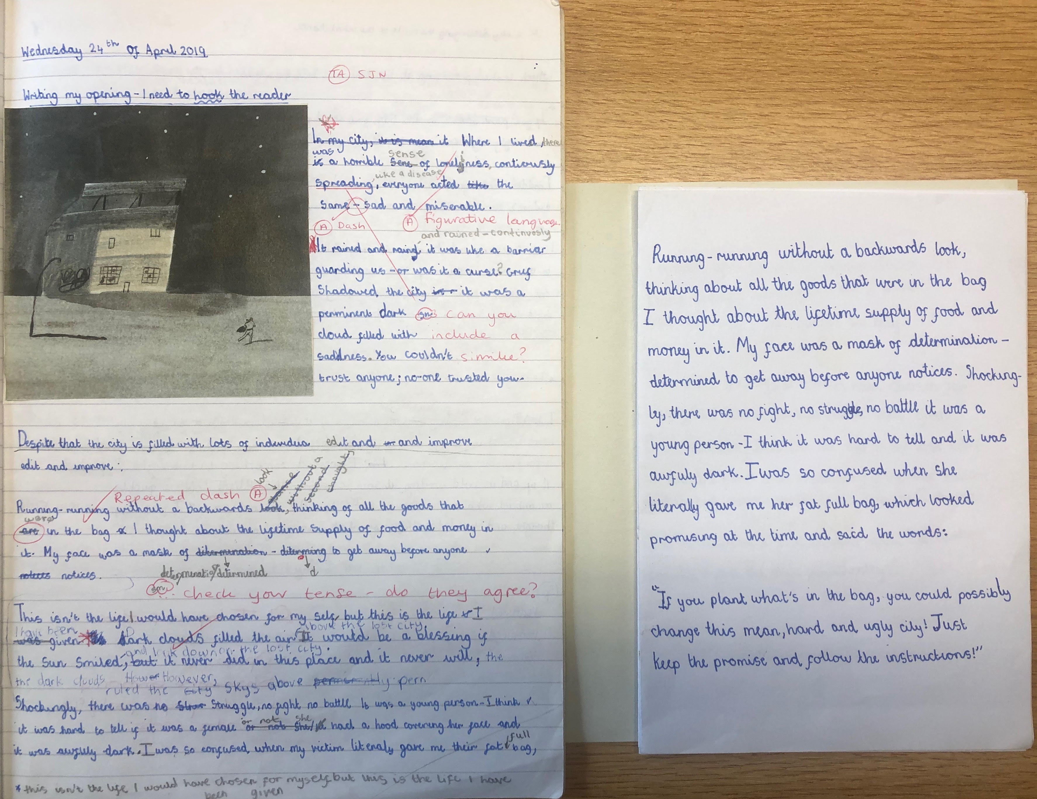

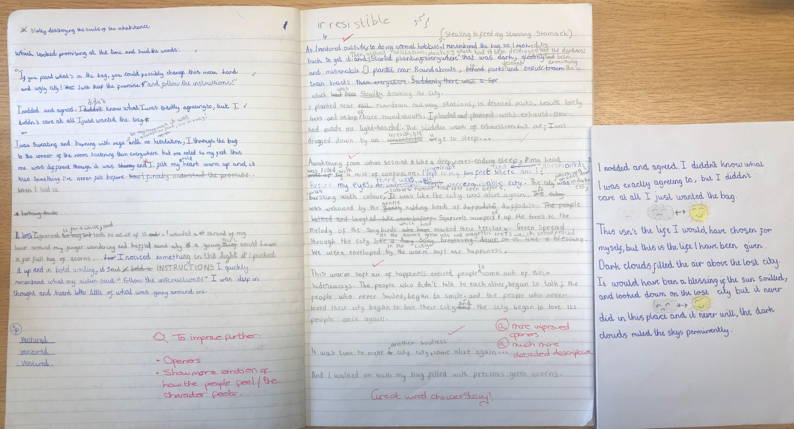

Agreed handwriting resources:
- When children are making effective progress in their formation of letters, they will achieve a goal of moving onto a handwriting pen. Confident writers may also achieve the goal of moving onto fountain pen, as referred to in the Handwriting policy:
When children are making effective progression in their formation of letters, they will achieve a goal of moving onto a handwriting pen. Confident writers may also achieve the goal of moving onto fountain pen.
- Children should have their own labelled, handwriting pen, to ensure this is the pen they have been using and are used to.
- Teachers to use chisel tip whiteboard pens to model handwriting on whiteboards.
- Teachers to model handwriting using the agreed handwriting books (Raspberry pink).
- Children to be provided with agreed handwriting lines appropriate for their needs as a guide to put under blank paper when writing up work in their best work.

How often do we do handwriting?
Handwriting sessions should last up to 15 Minutes – the key is ‘little but often’. Teachers and Teaching Assistants must demonstrate high expectations and reinforce the key elements for success regularly when writing is taking place.
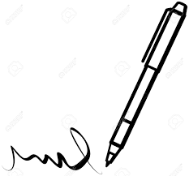
Good handwriting needs self discipline, skill and quality teacher input – consistency in delivering the key elements and having these high expectations will achieve our handwriting aims.

THE JOURNEY TO LONG TERM SUCCESS

What happens after our training is crucial to achieving excellent presentation skills across the curriculum. We have to realise and accept that improvement does require change. This is true in any walk of life. Whether you are an individual member of a team or if we talk about the team as a whole, improvement does require change and a willingness to accept change. It is pointless to continue doing what you have always done and hoping to do it a little bit better. The same applies to teaching materials. To continue using a type of exercise book which gives children no support or guidance with handwriting, just because you have always used these exercise books, is not a good reason for continuing to use them. Improvement requires change.

NEXT STEPS

Consistency is a key word.

Consistency in terms of the handwriting style and letter shapes being taught

Consistency in terms of how handwriting lessons are taught

Consistency in terms of the way teaching materials and writing tools are used

Consistency in terms of all members of staff supporting and believing in this drive for excellence in handwriting. It has to be seen that this is what we are doing as a staff. It has to be seen that this is something that is happening in every class. It has to be seen that this is something we all believe in. The more teachers give strong messages to pupils, showing they are really passionate about high quality presentation of work, the greater the likelihood of high standards being achieved.

FREQUENCY OF HANDWRITING LESSONS

For a school aiming to drive up standards of presentation, handwriting has to be taught intensively for a sustained period, if the initiative is to have the required impact.

'Do a little and do it often' is a key phrase. Doing a little means lessons of 15/20 minutes. Doing it often means doing at least four handwriting lessons per week, using the programme of lessons provided.

In Foundation stage, activities are taking place every day to develop gross motor skills, finger strength, fine motor skills and pencil control. Basic letter formation is addressed and taught during phonics and literacy lessons. In the final term of reception, children begin formal handwriting lessons.

If this level of intensity is maintained for the equivalent of half a term, ie. 6 or 7 weeks, a dramatic rise in standards will be seen very rapidly, not just in handwriting lessons, but in the way children present their work across the curriculum.

At the beginning of each new academic year or when needed e.g. after a lengthy school holiday or when English Leads feel standards in handwriting have slipped across the school- there must be a relaunch of the handwriting policy and approach, where all classes ensure they are implementing the writing policy rigorously for 4 days for 15/20 minutes, in order for it to have the desired impact. Throughout the term English leads will monitor if this is happening in all classes and if the desired impact is being achieved and the impact it is having on children’s presentation across the curriculum. In pupil progress meetings/Book watch meetings, English Leads will review how handwriting is going in each class with the class teacher, and whether the frequency of sessions can be reduced e.g., to 3 times a week or less. However, if the frequency of sessions is reduced handwriting and presentation should remain a priority and the handwriting policy should still be followed, and pupils are constantly reminded of the expectations. Some children may still need additional support, and this should be addressed and planned for e.g., HW interventions or HW KUNCU for individual pupils for specific letters etc. Handwriting sessions can also be used to practise focussed spellings, so other learning is being incorporated to prevent timetable restrictions.
In addition, where and when the frequency of handwriting sessions has been decreased in class, teachers need to continue to monitor the handwriting of their pupils, and if they recognise that handwriting standards have slipped in their own class, should have the freedom use their own professional judgement, perhaps after consultation with English Leads to re-establish high standards by having a week of daily handwriting lessons.

English Leads will also collect writing samples from each year group and create a portfolio to show year group expectations.

NEW MEMBERS OF STAFF

At the beginning of an academic year, most schools will have a number of new teachers or TAs. This can also happen during the school year. Newcomers need a comprehensive, thorough period of induction to the teaching of handwriting. This should consist of the following:

- Observing colleagues teach handwriting lessons, followed by paired discussion on teaching strategies modelled and how the lesson was structured.
- Team teaching with more experienced colleagues.
- Meeting with SLT members, focusing on the principles behind the whole school ethos of good presentation of work.
- The new member of staff being provided with the Excellence In Handwriting booklet and all teaching materials, with clear explanation of how to use them.

THREE LEVELS OF PRESENTATION FOR CHILDREN-

There are occasions when writing tasks or handwritten recording of work in different curriculum areas should be presented beautifully and times where presentation is less important. This is best explained by the three levels of presentation shown below.

- Highest level of presentation. For example, where the teacher says to the class, “With the Science investigation we have just finished, we are going to write it up beautifully with written explanations in your finest handwriting, with well constructed tables of results and carefully drawn diagrams. We are going to use plain paper of various sizes and line guides. I want you to feel really proud of your completed work and I want you to make your teacher very proud. I have a big, empty display board waiting for your work.”
- Middle level of presentation. This is where children work in exercise books/in Literacy three books/practising writing skills work in a literacy lessons/in SPAG sessions/books. There should be clear evidence of the school's handwriting style, with finger spaces and correct joins where they have been taught and if pupils are not applying skills this should be identified within the marking and feedback given to the child. KUNCU homework may need to be provided to individuals if a pupil is struggling with specific numbers/letters/joins
- Lowest level of presentation.
eg. Children are working in small groups with large sheets of sugar paper and marker pens. Teacher says, “ You have two minutes to write a superb sentence about the way the bare tree across the playground is moving in the January breeze.”

Children are writing at speed, inserting extra words to improve their sentence and
Perhaps crossing out. Presentation does not matter at all in this type of task.

With this type of task, the high quality of the top level of presentation should not be
expected or demanded, but the lowest level of presentation would be totally
unacceptable. Please see more guidance attached, to ensure we are making handwriting expectations clear and encouraging pupils to take pride in their work, but also making sure we are mindful of the levels of writing and ensure pupils are clear of the level they are expected to be writing in for tasks given.

ADULT HANDWRITING-

As with the three levels of presentation for children, there are times when adults in school must produce their finest handwriting and times when good handwriting matters less.

Top level of handwriting. During handwriting lessons or when producing handwritten labels to go with displays of children's work. When displaying sentence strips of teacher model examples/author’s examples or pupils examples - these should be written when possible in top level handwriting or middle level handwriting if being written during a Literacy session.

Middle level of handwriting. Handwritten comments in children's exercise books. These should be neatly written, using the school's handwriting style. If they are written untidily, they can be inaccessible to the children, making the written comment worthless. Badly written comments give children mixed and contradictory messages. Due to the time required to write perhaps thirty handwritten comments, it is unrealistic for these to be written to the top level standards. The same principles as the middle level of presentation for children's writing should apply here.

Lowest level of handwriting. This is where the quality of adult handwriting does not matter at all. eg. A guided writing activity. If a class or group of children are offering adjectives and adverbs in rapid succession to enhance a sentence, it would be counter productive for the adult to write slowly and meticulously in their most beautiful handwriting. Guided writing should be short, sharp and pacey. In this bottom level of handwriting, with crossings out, insertion of extra words and arrows to move sections of language within the sentence, the only criteria should be that the children are able to read what the adult has written.

TRANSFERING SKILLS FROM HANDWRITING LESSONS TO OTHER WRITING TASKS ACROSS THE CURRICULUM

Schools pursue an initiative to achieve excellence in handwriting not just so that it looks great in handwriting lessons; this would be teaching skills for the sake of teaching skills and totally worthless. The whole idea is for children to use the handwriting skills they have been taught in order to present work across the curriculum in an attractive way that develops feelings of personal pride.

How to achieve this. The three key words are: insist motivate expect

Insist on correct posture and correct sitting position throughout the school day
Insist on correct letter formation and correct letter joins in cross curricular writing
Insist on children producing their very best whenever it is required

Motivate children by giving copious amounts of praise when it is merited
Motivate children by telling them exactly what you are looking for.
Motivate children by showing them exactly what you are looking for
Motivate children by celebrating their efforts and achievements with displays of their written work, showing it is really valued.

Make it clear to children that what you expect from them is their very best at all times.
Make it clear to children that nothing less than their own best is acceptable.

Use the same lines for writing tasks as the ones used in handwriting lessons. This plays an enormous part in helping children to transfer handwriting skills to written work across the curriculum.

CLASSROOM ORGANISATION

- Ensure that all children have a good view of the teacher modelling during handwriting lessons. Children must be either facing the board or sideways on to it. No children should have their backs to the board. In a good Primary classroom, seating arrangements will be organised according to the nature of the task children are engaged in. School furniture is not set in concrete.

- Children need to have enough desk space when they are writing. Ensure that desks are uncluttered.

- Take left-handed children into consideration. Where children are sitting in pairs, the left- hander should be sitting to the left. This ensures that both left and right handed children have sufficient space to work comfortably.

- Ensure that there is sufficient natural light in the classroom. Open the blinds. They should only be closed if sunlight is shining directly into children's eyes.

- Ensure that children's writing is clearly visible in the classroom.

CELEBRATE CELEBRATE CELEBRATE

DISPLAY DISPLAY DISPLAY

Short term displays of children's handwriting practice, which can be rotated every
few days, act as a reward, motivation and examples of quality.
Displaying children's written work shows that writing is high priority and really
valued by the teacher.

REMEMBER, children learn best and reach their potential when:

Their learning base reflects effort and achievement

Their learning base reflects the teacher’s values

Their learning base reflects what is high priority in the school

HANDWRITING TOOLS

In order to produce excellent handwriting, children must have good quality tools.

HB Pencils

- Pencils must always be sharp. A pencil is not a pencil unless it has a point.
- Pencils must never be sharpened at both ends. This is dangerous and also shows complete disrespect for the writing tool.
- Pencils must not be too small for the child's hand.
- Pencils do not go in children's mouths!

It is good to give children responsibility for keeping their pencils sharp, but adults need to monitor this.

Pens-

We have opted to use Manuscript Handwriting pen (blue).

The pen has to be seen as a very special tool. The pen has to be seen by pupils as the most important tool they will use in school. The pen has to be seen as very precious. If the child looks after the pen, the pen will look after the child! Positive attitudes to the pen will only come if adults constantly reinforce these positive messages.

ESSENTIAL HABITS FOR DEVELOPING EXCELLENT HANDWRITING

- Two hands. Insist on children always using two hands when writing. One hand to hold the paper and one hand to write with.

  - Six feet. Children must always keep six feet on the floor. Their own two
feet and the chair's four feet. This means that the child does not kneel
or sit cross legged on the chair. Neither do they rock backwards or
forwards on the chair.

  - BBC. Ensure that children always sit in the BBC position – Bottom
Back in Chair. This means that they never sit with the chair sticking out
and their bottom on the front edge of the chair.

  - TNT. Tummy Near Table. This ensures that the child is sitting with their
body close to their work, instead of having to stretch forward to write.

  - Paper position. The paper should be upright when the child is writing or at an
angle not greater than 45 degrees. When children turn their paper to an angle
greater than this, it is often because the pencil is being held with the thumb in a
position which blocks the child's view of the pencil point.

Good posture and correct seating position are vital components of developing god handwriting. The habits above must not be seen just as good habits for handwriting. They must be insisted upon in all subject areas, throughout the school day, otherwise their impact is reduced. It has to be seen as the correct way, indeed the only way, rather than what is expected merely in handwriting lessons.

Key points from the November 2022 refresher Handwriting Training with Martin Harvey, and further guidance of our school handwriting expectations:

Hand writing expectations end of KS1:

Working towards the expected standard: form lower-case letters in the correct direction, starting and finishing in the right place • form lower-case letters of the correct size relative to one another in some of their writing • use

spacing between words.

Working at the expected standard: form capital letters and digits of the correct size, orientation and relationship to one another and to lower-case letters • use spacing between words that reflects the size of the letters.

Working at greater depth: use the diagonal and horizontal strokes needed to join some letters.

Hand writing expectations end of KS2:

Working towards the expected standard: write legibly

Working at the expected standard: maintain legibility in joined handwriting when writing at speed

Working at greater depth: There are no additional statements for Handwriting

Key Points from the training:

When children are issued with a pen, they need to have their ‘own’ and pupils should be held responsible for taking care of their pen.
Pens should be labelled with children’s name.

Pupils need to be taught how to use their pen correctly, so it does last.

Pupils should not move onto pen until they are ‘ready ‘and forming letters correctly.

Teachers need to be modelling the date when writing on the board neatly.

All exercise book labels need to be written neatly/letters formed correctly and in blue pen.

Timings of handwriting sessions:

'Do a little and do it often' is a key phrase. Doing a little means lessons of 15/20 minutes. Doing it often means doing at least four handwriting lessons per week, using the programme of lessons we provide.

If this level of intensity is maintained for the equivalent of half a term, ie. 6 or 7 weeks, a dramatic rise in standards will be seen very rapidly, not just in handwriting lessons, but in the way, children present their work across the curriculum.

Hand written labels must be written correctly and neatly. (Level 1 – highest level)

We are not changing to all exercise books being all in guidelines. As we have been advised by moderators it is ‘too’ scaffolded and also, we need to prepare pupils for a life without guidelines! However, provide pupils with guideline strips to stick in their books, if you want them to improve letter formation/or guidelines to use behind if this helps. Also, use the guidelines in to write up parts of writing for their wonderful writing books/or guidelines behind blank paper. Handwriting expectations needs to be consistent across the school for it to be successful. Handwriting needs to be celebrated.

1
Key points from the November 2022 refresher Handwriting Training with Martin Harvey, and further guidance of our school handwriting expectations:

The levels of writing for children and adults:

Our handwriting policy clearly outlines there are three levels of handwriting which need to be adhered to:
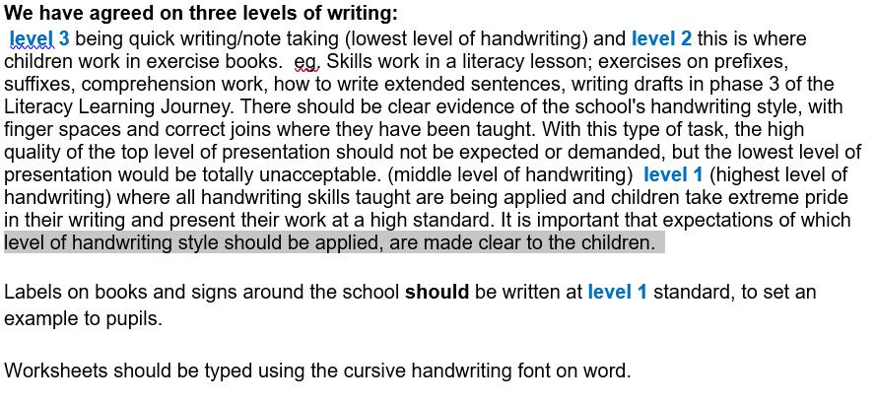

When note taking/quick recording, pupils can use level 3, as the focus of the task is what is important, not the handwriting and pupils will be doing this at speed.
When pupils are writing in their exercise books this is level 2 writing, as pupils need to be able to focus on applying skills and know this is a draft copy which can be edited and improved. Pupils should be encourage to cross out errors neatly/fix/edit & improve neatly.
When modelling writing, teaching staff should write at level 2 – and just explain to pupils it’s not your ‘best’ writing.
When marking teachers should write at level 2 (as teachers will being writing at some speed to provide immediate feedback. However, letters must be modelled correctly).
Staff should support each other with developing their own handwriting skills and not ridicule other staff’s handwriting – as handwriting might not be a strength for everyone. E.g. if you see a member of staff not forming a letter correctly, directly give the member of staff a gentle reminder/support if needed. Remember we all have our own handwriting style/habits… and it is hard to undo these.
But we do need to be adhering to the handwriting policy and be role models to the children – so no hearts replacing the tittle please!

*See the handwriting policy for more guidance on the above.

Writing sessions V’s handwriting sessions:

Obviously we want to promote pupils taking pride in their work – which is key with the Martin Harvey approach. Ensuring pupils look after their pens/holding pens correctly/ sitting correctly in order to write etc. However, we need to be extremely mindful in writing sessions, the main purpose of the session is to develop pupils ‘writing skills’.
If children are really working hard to achieve the writing objective during the session e.g. ‘writing a character description applying noun phrases’, then this should be the focus of feedback provided by an adult to begin with.
We DO NOT want to demotivate our young writers by focussing on their presentation straight away, especially if they have tried really hard practising/applying the writing skills they have been taught/asked to focus on.

2
Key points from the November 2022 refresher Handwriting Training with Martin Harvey, and further guidance of our school handwriting expectations:

Therefore sometimes, we do need to look beyond the handwriting to celebrate what the child has achieved. Especially pupils who have fine motor skill issues/social & emotional issues/processing issues/retention issues/SALT issues. Writing can be very challenging for pupils with the number of expectations required of them. The image below shows the thoughts of one of our pupils when asked what he is thinking about when he is writing.
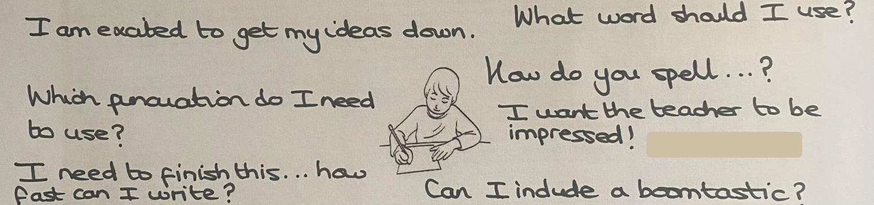

Child diagnosed with ADHD, age 7.

Guidance for the marking & feedback of handwriting:

Pupils may need more direction/focussed feedback about their handwriting rather than comments such as, check handwriting/improve presentation.
Individual pupils/pupils with individual needs could be asked to practise specific letters they are finding difficult/not forming correctly in their work. It would be useful to provide pupil with line guide strip stuck in their exercise book to carry out this practise, which they can look back on. (See example)

Or pupils could be asked to rewrite specific words/rewrite sentence again on line guide strip in book focusing on improving their handwriting.

Or there could be a whole class/or group letter focus or join focus (1-5 letters dependent of year group/children’s needs) for the session e.g. f, o and s are letters we have not be forming correctly – let’s really try and practise these and perfect these in our writing today…these could be modelled beforehand to remind the children of the letter formation. Or we have noticed we are not joining our oi correctly – let’s really try hard to do this today.

Pupils who are having handwriting intervention may focus on the letters they have been focussing on in their session staff leading handwriting interventions need to make teachers aware of these focusses so they can monitor to see how pupils are applying what they have been practising in the intervention in class.

Where needed, pupils could be provided with KUNCU to practise specific letters/numbers at home.

There will be cases where pupils may have not be putting enough effort into their writing/not taken pride in their work/or it is not legible – adults need to be proactive in sessions and remind pupils of the expectations, and that they need to be writing at level 2 in their exercise book and take pride in their work. But again, be mindful we don’t want to demotivate pupils with their writing, so think of strategies that will motivate pupils to take more pride e.g. they could have a buddy (role model) to check their work, and motivate them to improve the presentation of their work, pupils could create this is my level 1 writing/level 2 writing/level 3 writing pyramids (see

3
Key points from the November 2022 refresher Handwriting Training with Martin Harvey, and further guidance of our school handwriting expectations:

example, page 6) so they are clear of their own expectations/display pupil examples around the class.

The Wonderful Writing books are an opportunity for pupils to show off their ‘best’ level 1 handwriting. When pupils are writing up either their favourite sentence/paragraph/extracts from their drafts – create a calm, positive atmosphere for them to do this, where the focus is wholly on handwriting. This will probably be when you see pupils applying their handwriting skills correctly, and producing their ‘best’ handwriting as this is their main focus.
It’s also the perfect opportunity to celebrate pupils’ handwriting in these sessions - allow pupils to share their writing with each other/share pupils progress in handwriting e.g. pupils talk about which letters they have improved or mastered/display pupils best pieces around the class for all to see/share on class do jo for parents/carers to see.
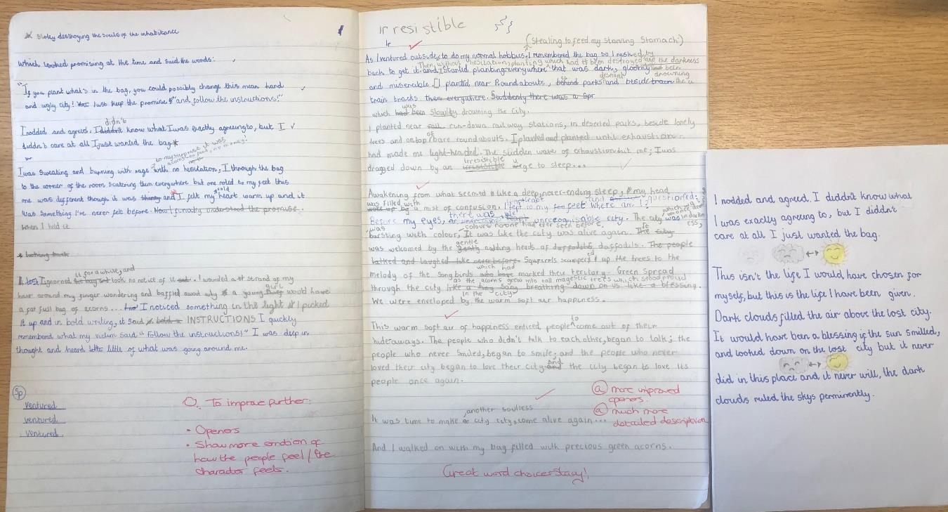

Reminders:

Pupils should not be editing and improving in their WW books, unless they have accidently made an error copying up – all editing and improving should be in their exercise book/draft pieces – as the above image shows the draft version compared to the published version for the WW book.

There should be no marking in WW books.

Pupils can write on guide lines (which can be found in teachers only handwriting folder) if this helps them produce their best handwriting or line guides can be used behind to support pupils. However, it is important to try and encourage children to not become too reliant with handwriting guide lines, as in life guidelines aren’t always at hand to use and pupils do need to practise being able to write without them e.g. writing greeting cards etc.

Handwriting is a writing expectation pupils’ need to achieve to meet writing standards. Handwriting does enhance an author’s writing, but it doesn’t automatically mean they are a better writer. Unfortunately, this can be the view taken by some people. An example of

4
Key points from the November 2022 refresher Handwriting Training with Martin Harvey, and further guidance of our school handwriting expectations:

this is a pupil was sent up to Y6 as a 2A writer, and another pupil was sent up a 2C writer. The 2A writer had beautiful handwriting but the content was not as strong as the 2C writer, but the 2C writer’s handwriting was untidy at times… as the child got lost in her writing but produced captivating writing. However, the 2C could write neatly when that was her only focus.
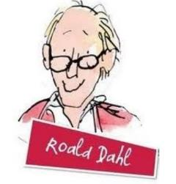

Roald Dahl is a very scruffy writer…but is one of the most successful authors in the world! This is not saying we are encouraging pupils to be scruffy, but just a reminder we may having budding authors whose handwriting isn’t as strong as some of their peers.

If hand writing sessions are consistent throughout the school, teaching staff

follow the handwriting policy/and this guidance, we all promote the same expectations and continue to motivate pupils to be writers… we will begin to see positive results. ☺

So let’s improve children’s handwriting – but still continue to motivate our little authors to be the best writers they can be! ☺

The English Leads (January 2023)

5

Key points from the November 2022 refresher Handwriting Training with Martin Harvey, and further guidance of our school handwriting expectations:




