

**Art /DT:**

**DT** – **Moving Parts- 3D playground models**

**Art – Traditional art techniques.**

**Study of a Summer Tree**

**Create a seaside collage**

**Humanities: Where in the UK**

**History/Geography Focus**

Building on our knowledge of the local area, plot the countries within the United Kingdom. Learn about the different countries within the UK The rise of the British holiday.

Florence Nightingale – Who was she and what did she do?

**Year 1 Summer Topic: Where in the UK?**

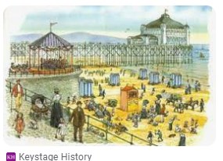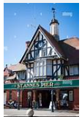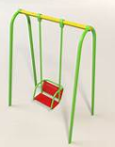

**RE:**

What does it mean to belong to a Faith Community?

**Writing Opportunities:** Stories from different cultures

Writing postcards

Holiday Review

Instructions – How to Make a Swing

Biography for Florence Nightingale and a Recount of St Anne’s Trip

**Science:**

Animals including Humans.

* Animal categories.
* Omnivores, carnivores and herbivores.

Seasonal Change

Summer

**Drama/S&L Opps:**

**Role Play: Scutari Hospital and Stories/Texts/links:**

The Train Ride,

Florence Nightingale

We’re Going on a Bear Hunt - Drama

**ICT:** Word Processing/

Creating Pictures

**PE and Music:**

Gym: Apparatus

Animal Dances

Music: Music Express Scheme

**Numeracy:**

