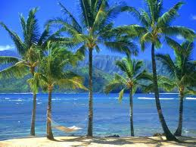

**Year 2 Topic: Wild about Animals**  
Summer 1 & 2 2025

**Art /DT:**

Art- A Tropical Adventure with Henri Rousseau

DT -

Vehicles -Axels and wheels.

**ICT: Computing**

Getting to know IT – Basic skills

Word Processing

Creating Pictures

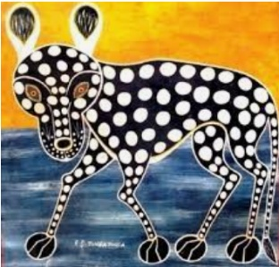

**Humanities:**

**History** – History of the seaside.

**Geography - Polar and Tropical Regions.**

Children are going to examine a globe and think about where the hottest and coldest places are.

They will consider why this might be and then look in more detail at these two habitats.

**PE**

Orienteering

Basketball

Athletics

Fitness

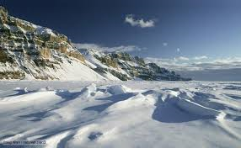

**Writing Opportunities:**

* Recount about Knowsley safari park Trip.
* Animal Poetry
* Setting description
* Story innovation.

**RE:** **How should we care for others and the world, and why does it matter.**

* What is special about our world?
* What can we learn from religions about deciding what is right and wrong?
* What matters most to Christians and Humanists?
* How and why should religious communities do more to care for the Earth?
* Does religion help people to be good?

**Music**

Summer 1

Weather & Pattern

Summer 2

Water& Travel

**Science:**  **Living things and their habitats**

**Food Chains.**

-All objects are either living, dead or have never been alive.

-Different habitats provide differing conditions for the animals that live there.

- Some animals are able to live in different habitats so you may find the same ones in different places.

- Within a habitat there are different micro-habitats.

- The plants and animals in a habitat depend on each other for food and shelter etc.

- The way that animals obtain their food from plants and other animals can be shown in a food chain.

**Numeracy Links:**

* Fractions
* Addition
* Subtraction
* Multiplication
* Division